SurveyTrak Specification Model
Updated 6 February 2024
Table of Contents
Table of Contents 1
Record of Edits 3
Overview 4
General Project Information 4
Projects 4
Instruments 4
Main Instrument 4
Observations Instrument 4
Checklist of Features 5
Pre-Load 5
SurveyTrak Data Preload 5
Blaise Main Preload 5
Blaise Observations Preload 5
Blaise Data Pulls 6
Main Instrument 6
Observations Instrument 6
Suspend Variable 6
SurveyTrak Features/Modules 6
Standard SurveyTrak Tabs 6
Sample Tab 7
Address Tab 8
Transfer Lines Tab 9
Transfer History Tab 9
Finalized Tab 10
View/Edit Tabs & Windows 10
Tab Order 10
Call Info Tab 11
Address Tabs Specifications 11
Respondent Address Tab 11
Contact 1 Address Tab 12
Contact 2 Address Tab 13
RCLS Follow Up Tab 14
Contact Attempt Windows Tab 14
All Notes 15
Call Wizard 16
Call Info Window 16
Pre-Disposition Actions 18
Post-Disposition Actions 19
Optional Features/Modules 19
DRI (Digitally Recorded Interviews) 19
Flagging for Recording 19
BCI File (Capture List) 20
Burn to Disk Instructions 20
Electronic Documents (EDU) 20
Find 20
Interviewer Projection Tool (IPT) 20
Letters 20
Letter Request Form 21
Line Spawning 22
Locating 22
Payments 22
Wizard Driven Payments 23
Interviewer Requested (Edit -> Payments) 24
RCLS (Respondent Contact Logging System) 26
Reason for Transfer 26
Related Case Details 27
Respondent Profiles 27
TL Approval 27
Verification 28
Result Codes 28
Result Types 29
Result Flags 29

Record of Edits
Date | Name | Notes

Overview
About This Document
Information in this document is displayed in multiple formats (tables, images, narrative) whenever possible. Since most images are based on screen shots from existing SurveyTrak projects, there may be inconsistencies between what an image displays and what a table specifies. In these cases the table information should be considered more accurate.

Norms
Code vs. label: When we have the option of either storing a code (numeric value) or a label (text) we will store the code and display the label. For example, 1=Yes, 0=No – We will store either 1 or 0 in the tables and display Yes or No in the application. One exception is result codes – we store AND display the code.
Formatted data (masks): Formatting for dates and telephone numbers are as follows:
  - Dates: mm/dd/yyyy
  - Telephone numbers: (###) ###-####

Legend
The following symbols are used in this document:
 Indicates that the feature is “locked” and cannot be customized.
 Indicates a customizable feature that is typically customized for each project. Please pay particular attention to these sections.

 Indicates that the information will be provided by the Technical Services Group (TSG).

General Project Information
Projects
Projects | Sample ID Format |  Project ID
Pretest | xxxx-xxx | SRC.SRO.DEMO.PRETEST
Training | xxxx-xxx | SRC.SRO.DEMO.TRAIN
Certification | xxxx-xxx | SRC.SRO.DEMO.CERT
Production | xxxx-xxx | SRC.SRO.DEMO.PROD

Instruments
Main Instrument
Instrument Type | Required for this project?
Blaise Screener | No  Allow Retakes: n/a
Blaise Main | Yes  Allow Retakes: Yes
Observations Instrument
Instrument Type | Required for this project?
Blaise Contact Obs | Yes
Blaise Post-IW (Iwer) Obs | Yes

Checklist of Features
Feature/Module | Required for Pretest? | Required for Training? | Required for Production?
DRI (Digitally Recorded Interviews) | Yes | Yes | Yes
Electronic Documents (EDU) | No | Yes | No
Find | No | No | No
Interviewer Projection Tool (IPT) | No | No | Yes
Letters | No | Yes | Yes
Line Spawning | No | No | No
Locating | No | Yes | Yes
Payments | Yes | Yes | Yes
RCLS (Respondent Contact Logging System) | Yes | No | Yes
Reason for Transfer | No | No | Yes
Related Case Details | No | No | No
Respondent Profiles | No | Yes | Yes
TL Approval | No | No | Yes

Pre-Load
SurveyTrak Data Preload
The SurveyTrak preload is documented in the following location:
Blaise Main Preload
The Blaise instrument preload is documented in the following location:
Blaise Observations Preload
Observations preload is created dynamically by SurveyTrak when launching the Observations instrument. The base preload format is as follows:

 | Position | Field Name |  SurveyTrak DB Column
 | 1 | SampleID | tsample_line.vsamplelineid
 | 2 | CallNum | tcallinformation.ncallinfoid
 | 3 | ResultCode | tsample_line.sresultcode
 | 4 | IW_InstID | tsample_line.siwinstid
 | 5 | S_attr1 | tsample_line.ssampletype1
 | 6 | S_attr2 | tsample_line.ssampletype2
 | 7 | S_attr3 | tsample_line.ssampletype3
 | 8 | S_attr4 | tsample_line.ssampletype4
 | 9 | FirstCon | (calculated based on all existing calls)
 | 10 | FirstRef | (empty)
 | 11 | Mode | tsample_line.slastcallmode
 | 12 | HH_Screened | tsample_line.bhh_screen
 | 13 | Call_Result_Date | tsample_line.dresultdate
Additional preload is not required for this project.

Blaise Data Pulls
This project will need interview data to be pulled into SurveyTrak from both the Main Instrument and the Observations Instrument (“BCP Pull”).
Main Instrument
See also the Verification section.

Instrument Field Name | Blaise Codeframe |  SurveyTrak DB Column | SurveyTrak Display
Section_D.D5 | 1=Yes, 5=No | tsample_line.vext_025 | n/a
Section_G.G2 | 1=Rent, 2=Own, 3=Neither | tsample_line.vext_026 | n/a
Observations Instrument
Data pulled from the Observations instrument is displayed in the All Notes window.

Instrument Field Name |  SurveyTrak DB Column
RComm_Time | tcallinformation.blobs_time
RComm_Interest | tcallinformation.blobs_interest
RComm_Confidential | tcallinformation.blobs_confidential
RComm_Sensitive | tcallinformation.blobs_sensitive
RComm_Purpose | tcallinformation.blobs_purpose
RComm_Govt | tcallinformation.blobs_govt
RComm_WhyMe | tcallinformation.blobs_whyme
RComm_Voluntary | tcallinformation.blobs_voluntary
RComm_Incentive | tcallinformation.blobs_incentive
RComm_None | tcallinformation.blobs_none
RComm_Other | tcallinformation.blobs_other
RComm_Spec | tcallinformation.vobs_otherspecify
RQuestions | tcallinformation.blobs_questions

Suspend Variable
When suspending Blaise, this project should also pull the Blaise variable CurrentFieldName from Blaise into:
- tsample_line.viwsupendvariable
- tcallinformation.viwsuspendvariable
- Also set tcallinformation.bliw_suspended to 1.

SurveyTrak Features/Modules
Standard SurveyTrak Tabs
Sample Tab
The Sample tab displays non-finalized lines. Lines will move to the Finalized tab once a call record with a final result code is entered. If a line is finalized but the observations are not complete, the line will stay on the Sample tab until observations are completed.

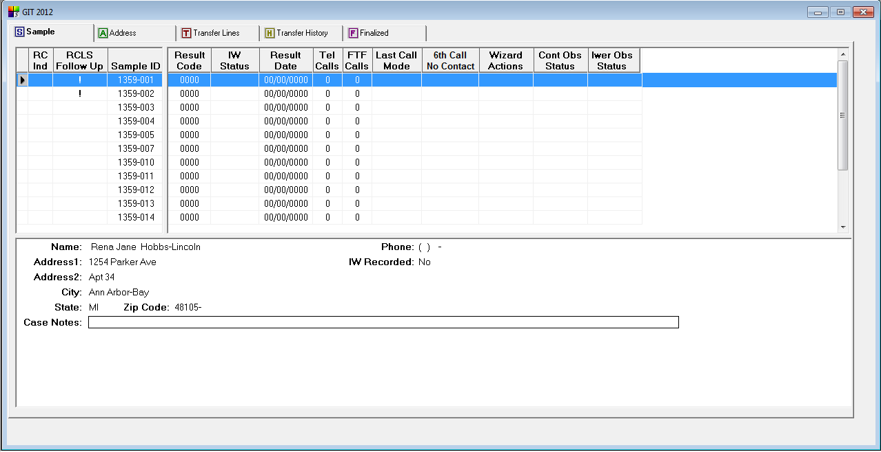

Top Pane
Column Heading |  SurveyTrak DB Column | Notes
RC Ind | tsample_line.blrcindflag | LOCK column
RCLS Follow Up | (calculated) | LOCK column
Sample ID | tsample_line.vsamplelineid | LOCK column; default sort
Result Code | tsample_line.sresultcodeid
IW Status | tsample_line.siwinststatus | 0=Complete, 1=Suspend, 2=Problem
Result Date | tsample_line.dresultdate
Tel Calls | tsample_line.sitelcalls
FTF Calls | tsample_line.sifacetoface
Last Call Mode | tsample_line.slastcallmode | 1=TEL, 2=FTF
Language | tsample_line.sinterviewlanguage | 1=English, 2=Spanish, 3=Other (Note: This codeframe is required by Olive.)
6th Call No Contact | tsample_line.inocontactcount | 6 consecutive No Contact result codes
Wizard Actions | tsample_line.vwizardactionflags
Cont Obs Status | tsample_line.scon_obs_sum_status | 0=Complete, 1=Suspend, 2=Problem, 3=Incomplete
Iwer Obs Status | tsample_line.spio_status | 0=Complete, 1=Suspend, 2=Problem, 3=Incomplete

Bottom Pane

Values are from the Respondent Address tab in View/Edit (where spersontype = ‘R’).
Column | Label |  SurveyTrak DB Column | Notes
1 | Name | tsample_line_address
1 | Address1 | tsample_line_address.vaddressline1
1 | Address2 | tsample_line_address.vaddressline2
1 | City | tsample_line_address.vcity
1 | State | tsample_line_address.sstate
1 | Zip Code | tsample_line_address.spostalcode
all | Case Notes | tsample_line.lvcasenotes
2 | Phone | tsample_line_address.sphone
Address Tab
- The Address tab displays the same lines as the Sample tab, minus finalized lines.
- Values are from the Respondent Address tab in View/Edit (where spersontype = ‘R’).

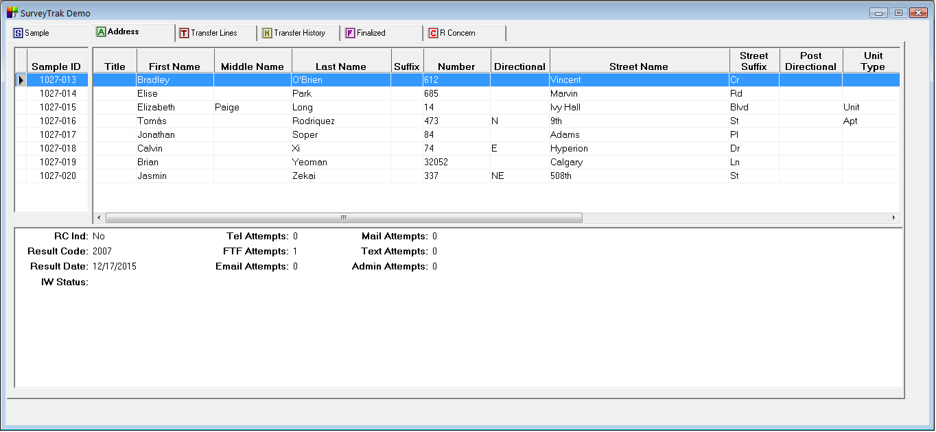

Top Pane
Column Heading |  SurveyTrak DB Column | Notes
Sample ID | tsample_line.vsamplelineid | LOCK column; default sort
Title | tsample_line_address.stitle_long
First Name | tsample_line_address.vfirstname
Middle Name | tsample_line_address.vmiddlename
Last Name | tsample_line_address.vlastname
Suffix | tsample_line_address.ssuffix
Number | tsample_line_address.vusps_primary_address_number
Directional | tsample_line_address.vusps_predirectional
Street Name | tsample_line_address.vusps_street_name
Street Suffix | tsample_line_address.vusps_street_suffix
Directional | tsample_line_address.vusps_postdirectional
Unit Type | tsample_line_address.vusps_secondary_address_type
Unit | tsample_line_address.vusps_secondary_address
City | tsample_line_address.vcity
State | tsample_line_address.sstate
Zip | tsample_line_address.spostalcode
Phone | tsample_line_address.sphone
Email | tsample_line_address.vemail

Bottom Pane
Column | Label |  SurveyTrak DB Column | Notes
1 | RC Ind | tsample_line.blrcindflag
1 | Result Code | tsample_line.sresultcodeid
1 | Result Date | tsample_line.dresultdate
1 | IW Status | tsample_line.siwinststatus | 0=Complete, 1=Suspend, 2=Problem
2 | Tel Attempts | tsample_line.sitelcalls
2 | FTF Attempts | tsample_line.sifacetoface
2 | Email Attempts | tsample_line.siemailcalls
2 | Mail Attempts | tsample_line.simailcalls
2 | Text Attempts | tsample_line.sitextcalls
2 | Admin Attempts | tsample_line.siadmincalls

Transfer Lines Tab
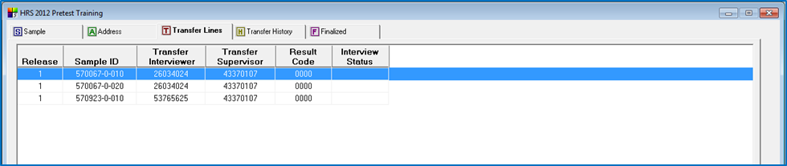

Column Heading |  SurveyTrak DB Column | Notes
Release | tsample_line.srelease
Sample ID | tsample_line.vsamplelineid
Transfer Interviewer | tsample_line.siwersubscribeid
Transfer Supervisor | tsample_line.stransfersup
Result Code | tsample_line.sresultcodeid
Interview Status | tsample_line.siwinststatus

Transfer History Tab
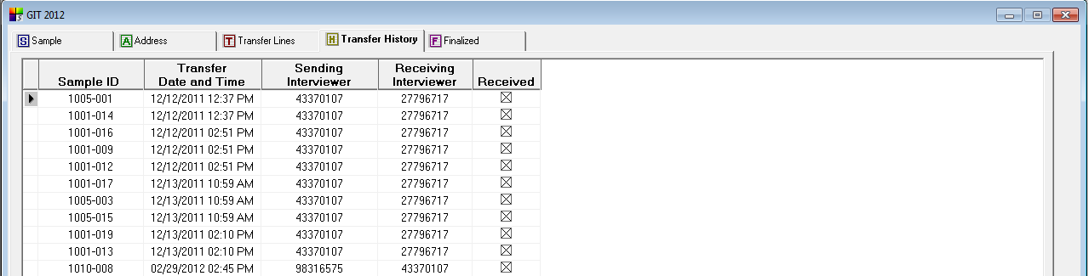

Column Heading |  SurveyTrak DB Column | Notes
Sample ID | tsample_line.vsamplelineid
Transfer Date and Time | ttransferhistory.tstransferdate
Sending Interviewer | tsample_line.siwersubscribeid
Receiving Interviewer | tsample_line.stransferiwer
Received | ttransferhistory.blrecvdconfirmation

Finalized Tab
The Finalized tab displays lines where a call record with a final result code has been entered. If the call record required observations but the observations were not completed, the line stays on the Sample tab until the observations are complete.
 The Top and Bottom panes of the Finalized tab are the same as the Sample tab. Please see Sample Tab the section.

View/Edit Tabs & Windows
Tab Order
 From left to right:
- Call Info
- Respondent Address
- Contact 1 Address
- Contact 2 Address
- RCLS Follow Up
- Contact Attempt Windows

Call Info Tab
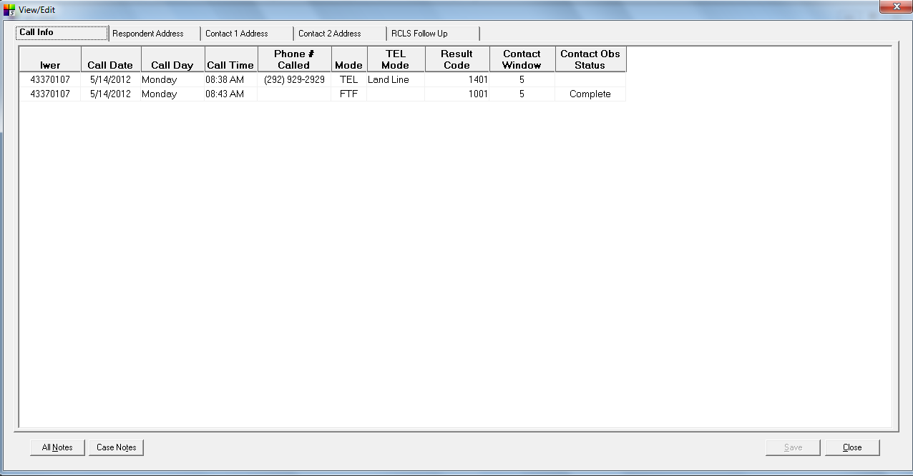

Information from the Call Info tab comes from the top pane of the Call Info window. Please note that Call Info is view-only here.
Address Tabs Specifications
In the address tabs below, the codeframe for phone types is: 1=Home, 2=Work, 3=Cell, 4=Pager, 5=Fax

Respondent Address Tab
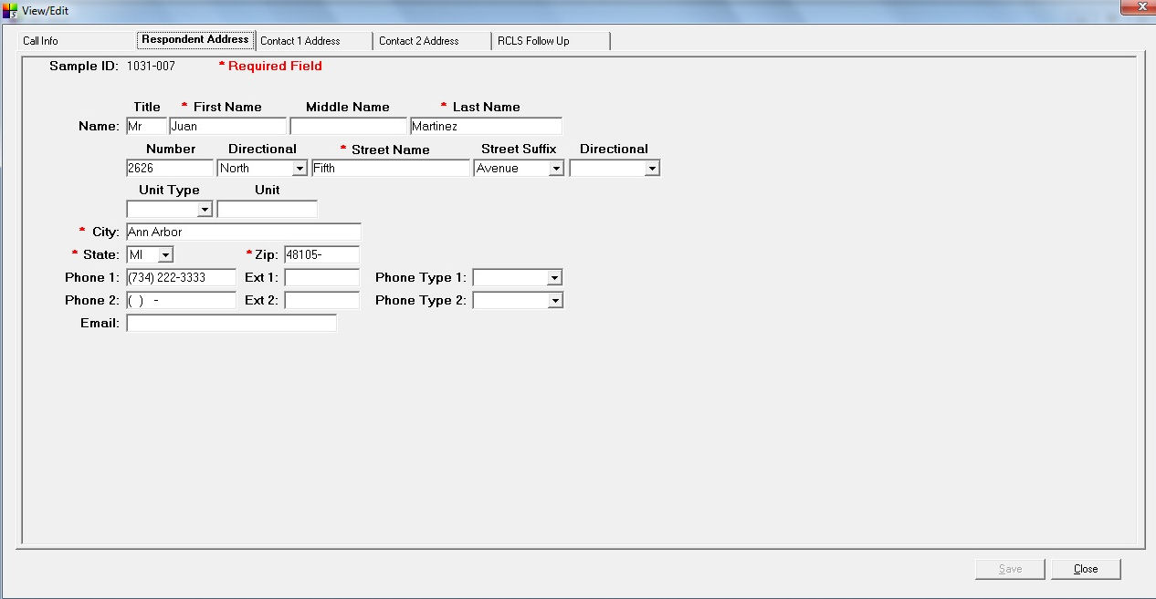

 The person type is R.
The fields to be displayed are:

Label  * = required field |  SurveyTrak DB Column | Notes
Sample ID | tsample_line_address.vsamplelineid
Title | tsample_line_address.stitle_long
*First Name | tsample_line_address.vfirstname
Middle Name | tsample_line_address.vmiddlename
*Last Name | tsample_line_address.vlastname
Number | tsample_line_address.vusps_primary_address_number
Directional | tsample_line_address.vusps_predirectional
*Street Name | tsample_line_address.vusps_street_name
Street Suffix | tsample_line_address.vusps_street_suffix
Directional | tsample_line_address.vusps_postdirectional
Unit Type | tsample_line_address.vusps_secondary_address_type
Unit | tsample_line_address.vusps_secondary_address
*City | tsample_line_address.vcity
State | tsample_line_address.sstate
*Zip | tsample_line_address.spostalcode
Phone 1 | tsample_line_address.sphone
Ext 1 | tsample_line_address.sphoneextension
Phone Type 1 | tsample_line_address.sphonetype1
Phone 2 | tsample_line_address.sphone2
Ext 2 | tsample_line_address.sphone2extension
Phone Type 2 | tsample_line_address.sphonetype2
Email | tsample_line_address.vemail

Contact 1 Address Tab
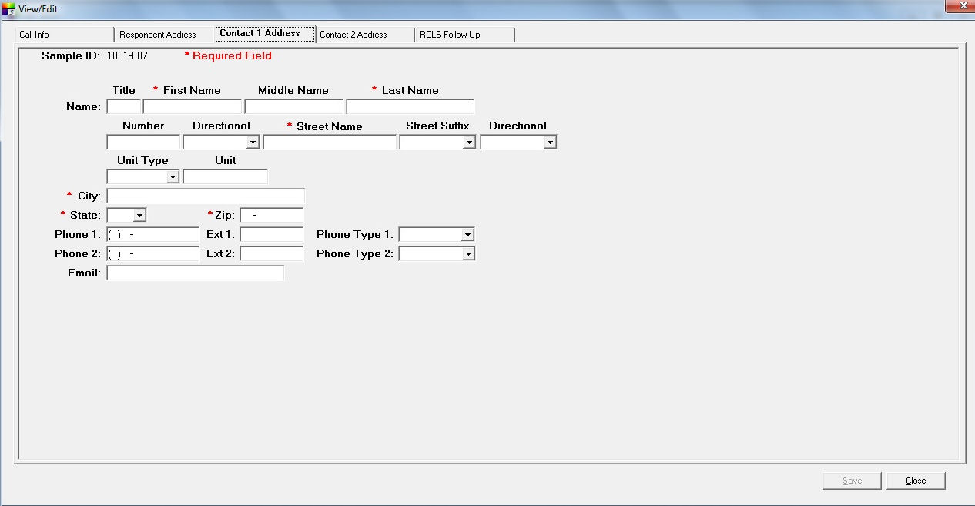

 The person type is C1.
The fields to be displayed are:

Label  * = required field |  SurveyTrak DB Column | Notes
Sample ID | tsample_line_address.vsamplelineid
Title | tsample_line_address.stitle_long
*First Name | tsample_line_address.vfirstname
Middle Name | tsample_line_address.vmiddlename
*Last Name | tsample_line_address.vlastname
Number | tsample_line_address.vusps_primary_address_number
Directional | tsample_line_address.vusps_predirectional
*Street Name | tsample_line_address.vusps_street_name
Street Suffix | tsample_line_address.vusps_street_suffix
Directional | tsample_line_address.vusps_postdirectional
Unit Type | tsample_line_address.vusps_secondary_address_type
Unit | tsample_line_address.vusps_secondary_address
*City | tsample_line_address.vcity
State | tsample_line_address.sstate
*Zip | tsample_line_address.spostalcode
Phone 1 | tsample_line_address.sphone
Ext 1 | tsample_line_address.sphoneextension
Phone Type 1 | tsample_line_address.sphonetype1
Phone 2 | tsample_line_address.sphone2
Ext 2 | tsample_line_address.sphone2extension
Phone Type 2 | tsample_line_address.sphonetype2
Email | tsample_line_address.vemail
Contact 2 Address Tab
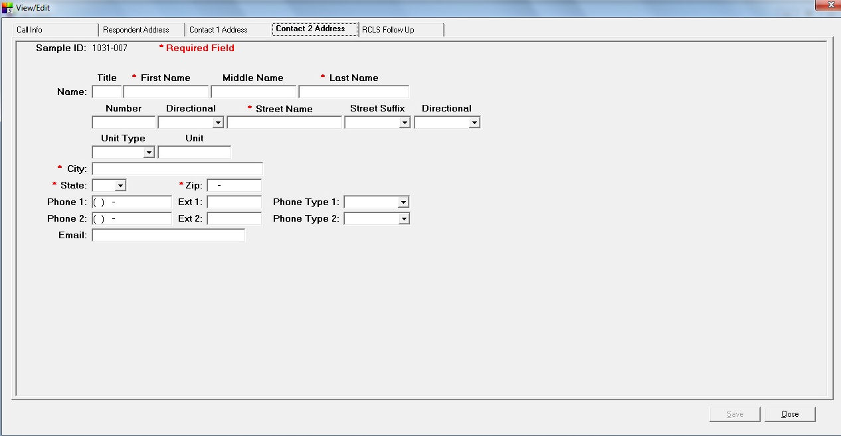

 The person type is C2.
The fields to be displayed are:

Label  * = required field |  SurveyTrak DB Column | Notes
Sample ID | tsample_line_address.vsamplelineid
Title | tsample_line_address.stitle_long
*First Name | tsample_line_address.vfirstname
Middle Name | tsample_line_address.vmiddlename
*Last Name | tsample_line_address.vlastname
Number | tsample_line_address.vusps_primary_address_number
Directional | tsample_line_address.vusps_predirectional
*Street Name | tsample_line_address.vusps_street_name
Street Suffix | tsample_line_address.vusps_street_suffix
Directional | tsample_line_address.vusps_postdirectional
Unit Type | tsample_line_address.vusps_secondary_address_type
Unit | tsample_line_address.vusps_secondary_address
*City | tsample_line_address.vcity
State | tsample_line_address.sstate
*Zip | tsample_line_address.spostalcode
Phone 1 | tsample_line_address.sphone
Ext 1 | tsample_line_address.sphoneextension
Phone Type 1 | tsample_line_address.sphonetype1
Phone 2 | tsample_line_address.sphone2
Ext 2 | tsample_line_address.sphone2extension
Phone Type 2 | tsample_line_address.sphonetype2
Email | tsample_line_address.vemail

RCLS Follow Up Tab
This project displays the standard RCLS Follow Up tab.

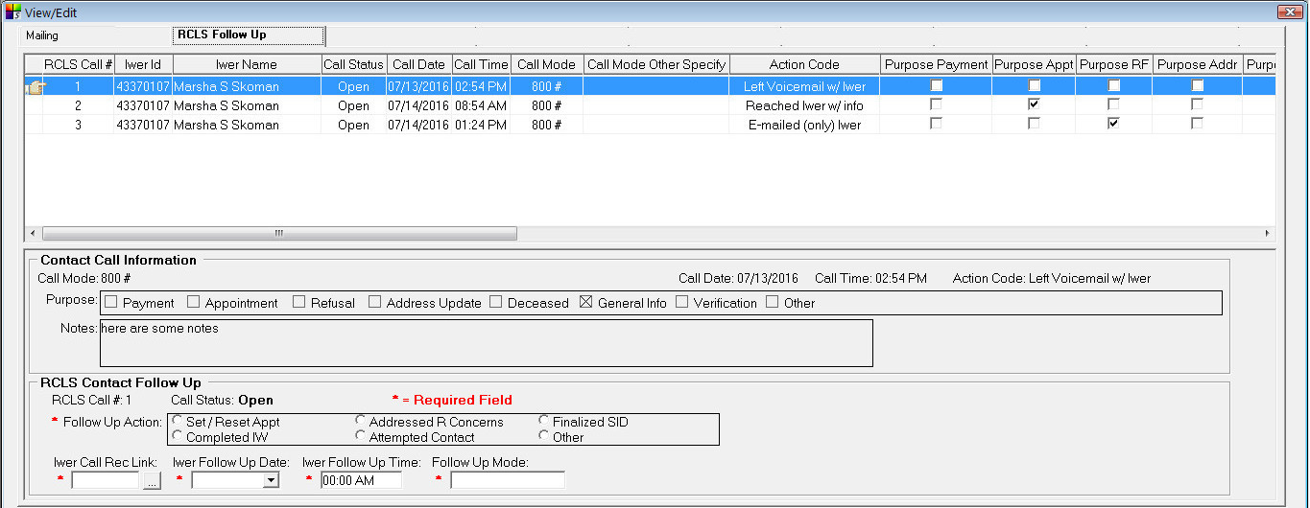

Contact Attempt Windows Tab
This project displays the standard Contact Attempt Windows tab.

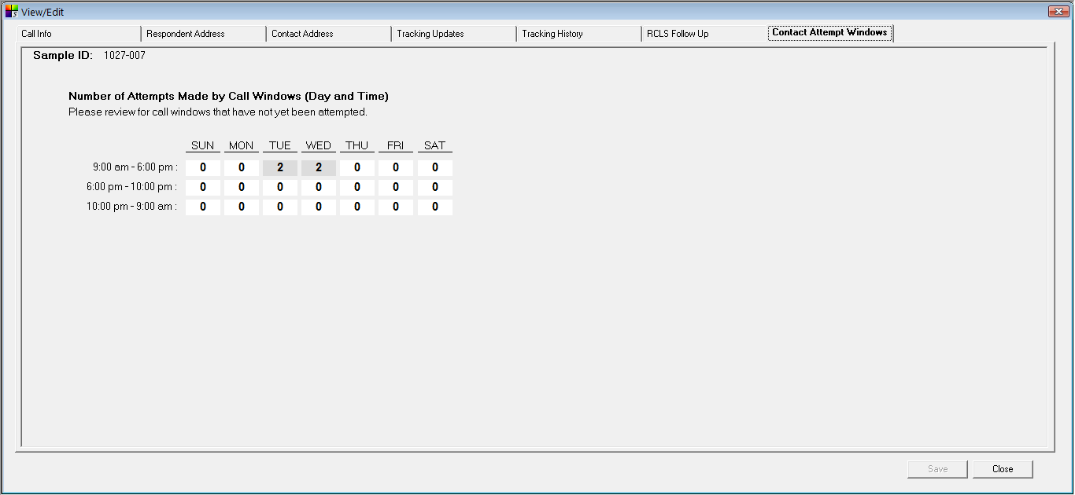

All Notes
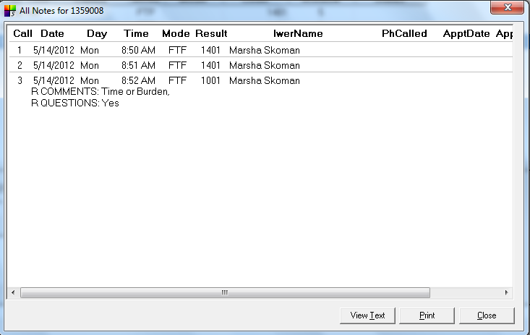

The fields to be displayed are:

Label |  SurveyTrak DB Column | Notes
Call | tcallinformation.ncallinfoid
Date | tcallinformation.dresultdate
Day | (calculated)
Time | tcallinformation.tresulttime
Mode | tcallinformation.scallmode
Result | tcallinformation.sresultcodeid
Inb | tcallinformation.blinbound
Iwer Name | temployee.vfirstname, temployee.vlastname
Contact Details | tcallinformation. vcontactmodedetail
ApptDate | tcallinformation.dapptdate
ApptTime | tcallinformation.tappttime
Notes | tcallinformation.lvnotes + BCP pulls of observations (see list below) | See also Observations Instrument
RComm_Time, RComm_Interest, RComm_Confidential, RComm_Sensitive, RComm_Purpose, RComm_Govt, RComm_WhyMe , RComm_Voluntary , RComm_Incentive, RComm_None , RComm_Other, RComm_Spec, RQuestions

Call Wizard
Call Info Window

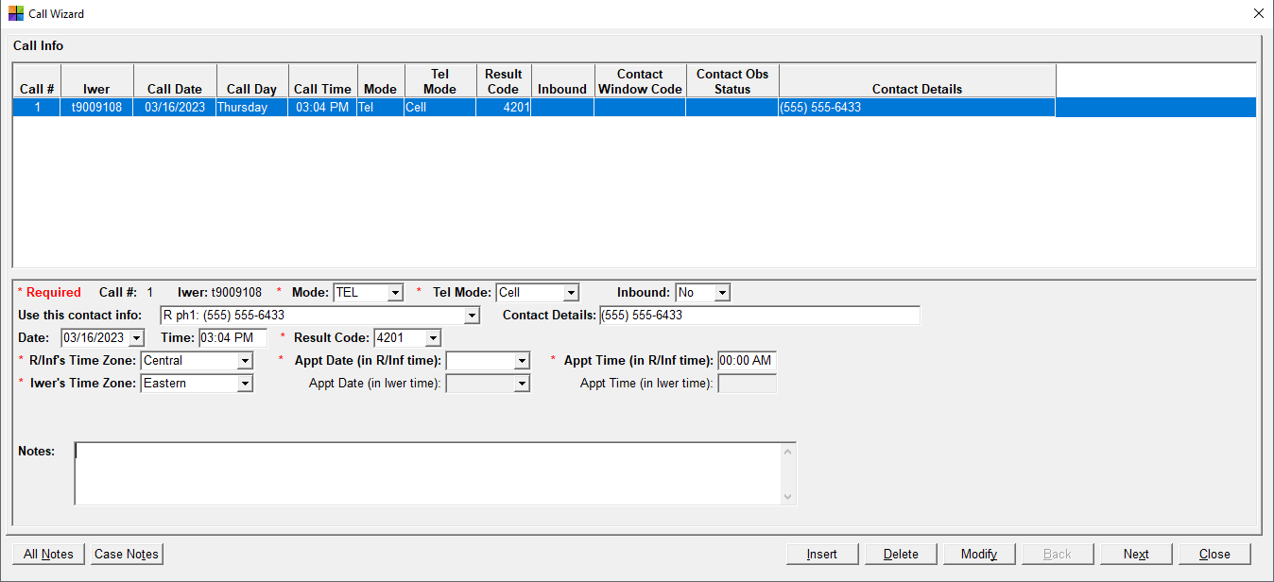

Top Pane
Column Heading |  SurveyTrak DB Column | Notes
Call # | tcallinformation.icallinfodisplayorder
Iwer | tcallinformation.sinterviewereremployeeid
Call Date | tcallinformation.dresultdate
Call Day | (calculated) | Calculated from tCallInformation.dResultDate
Call Time | tcallinformation.tresulttime
Mode | tcallinformation.scallmode | 1=TEL, 2=FTF, 3=Email, 4=Admin, 5=Mail, 6=Text
Tel Mode | tcallinformation.vtelmode | 3=Cell, 4=Land Line, 6=VOIP, 5=Don’t Know
Result Code | tcallinformation.sresultcodeid
Inbound | tcallinformation.blinbound | 0=No, 1=Yes
Contact Window Code | tcallinformation.nconcd | Values = 1, 2, 3, 4, or 5 (see Contact Window Code below)
Contact Obs Status | tcallinformation.siwerobsstatus | 0=Complete, 1=Suspend, 2=Problem, 3=Incomplete
Contact Details | tcallinformation.vcontactmodedetail

Bottom Pane

Row | Label  *=required |  SurveyTrak DB Column | Notes
1 | Call # | tcallinformation.  icallinfodisplayorder
1 | Iwer | tcallinformation.  sinterviewereremployeeid
1 | *Mode | tcallinformation.scallmode | 1=TEL, 2=FTF, 3=Email, 4=Admin, 5=Mail, 6=Text
If Mode = TEL:
1 | *Tel Mode | tcallinformation.vtelmode | 3=Cell, 4=Land Line, 6=VOIP, 5=Don’t Know
All Modes
1 | Inbound | tcallinformation.blinbound | 0=No, 1=Yes. Default to No.
2 | Use this contact info | n/a | Dropdown list of all available addresses, phone numbers, and emails. Fill based on mode:  1=TEL – all telephone numbers  2=FTF – all mailing addresses  3=Email – all e-mails  5=Mail – all mailing addresses  6=Text – all telephone numbers  If 4=Admin – hide dropdown
2 | Contact Details | tcallinformation. vcontactmodedetail | Prefilled when info is selected from “Use this contact info” dropdown. Can be edited/overwritten.  If mode is 4=Admin – hide this field
3 | Date | tcallinformation.dresultdate | When in Call Info after an interview: Default to date that IW was started and disabled editing.
3 | Time | tcallinformation.tresulttime | When in Call Info after an interview:  Default to time that IW was started and disable editing.
3 | *Result Code | tcallinformation.sresultcode
4 | R/Inf’s Time Zone | tcallinformation.  ntimezone_r | Default to R time zone in tsample_line_address. ntimezone_code_r. Allow iwer to change. Values:  99.00 = Other  -4.00 = Atlantic Time  -5.00 = Eastern Time  -6.00 = Central Time  -7.00 = Mountain Time  -8.00 = Pacific Time  -9.00 = Alaskan Time  -10.00 = Hawaiian Time
4 | *Appt Date (in R/Inf time) | tcallinformation.dapptdate | Field activated only when the result code’s type is AP
4 | *Appt Time (in R/Inf time) | tcallinformation.tappttime | Field activated only when the result code’s type is AP
5 | *Iwer’s Time Zone | tcallinformation.ntimezone_iwer | Allow iwer to change. Values:  99.00 = Other  -4.00 = Atlantic Time  -5.00 = Eastern Time  -6.00 = Central Time  -7.00 = Mountain Time  -8.00 = Pacific Time  -9.00 = Alaskan Time  -10.00 = Hawaiian Time
5 | Appt Date (in Iwer time) | tcallinformation. diwerapptdate | Field activated only when the result type of the result code is AP. Read-only. Updated by SurveyTrak when the call record is saved.
5 | Appt Time (in Iwer time) | tcallinformation. tiwerappttime | Field activated only when the result type of the result code is AP. Read-only. Updated by SurveyTrak when the call record is saved.
6 | Broken Appointment | tcallinformation. vbrokenappointment | Display dropdown when adding a call after a hard appointment call.  Values: Inf, R/Proxy, Iwer, Suspended IW, Confirm/Reminder, Rescheduled, Other
7 | Notes | tcallinformation.lvnotes

Contact Window Code
 Application-level codes – cannot be modified for project-specific use.
Contact Window Code = 1 if Result Date = Sunday thru Thursday & Result Time = 6:00PM thru 9:59PM
Contact Window Code = 2 if Result Date = Friday thru Saturday & Result Time = 6:00PM thru 9:59PM
Contact Window Code = 3 if Result Date = Saturday thru Sunday & Result Time = 9:00AM thru 5:59PM
Contact Window Code = 4 if Result Date = Monday thru Friday & Result Time = 9:00AM thru 5:59PM
Contact Window Code = 5 if Result Date = Sunday thru Saturday & Result Time = 10:00PM thru 8:59AM
Sunday | Monday | Tuesday | Wednesday | Thursday | Friday | Saturday
9am-6pm | 9am-6pm | 9am-6pm | 9am-6pm | 9am-6pm | 9am-6pm | 9am-6pm
6pm-10pm | 6pm-10pm | 6pm-10pm | 6pm-10pm | 6pm-10pm | 6pm-10pm | 6pm-10pm
10pm-9am | 10pm-9am | 10pm-9am | 10pm-9am | 10pm-9am | 10pm-9am | 10pm-9am

Pre-Disposition Actions
Pre-disposition actions appear in the call wizard after the interview and before the Call Info tab.
 Suspended Interview
- Respondent Address
- Call Info

 Completed Interview
- Respondent Address
- Contact 1 Address
- Contact 2 Address
- Token of Appreciation
- Call Info
Post-Disposition Actions
- Post-disposition actions appear in the call wizard after the result code is entered in Call Info tab.
- See also the Obs Call Mode column of the Result Codes table.
 Observations will be required for every contact.

Result Codes | Post-Disposition Action(s)
1001 1005 | Contact Obs, Post-IW Obs
4001 | Contact Obs
4201 | Contact Obs
4301 | Contact Obs
5001 | Contact Obs, Post-IW Obs
6001 6005 | Contact Obs, Post-IW Obs

Optional Features/Modules

DRI (Digitally Recorded Interviews)
This project will digitally record interviews.
Flagging for Recording
 Indicate whether 100% of cases should be flagged for recording or whether cases should be flagged based on specific flagging rules (see Flagging Rules Example below).
Flagging Rules Example:

Initial number of interviews to be recorded | 5
Rate after initial number is reached and until total is reached | 50%
Total number of interviews to be recorded | 20
- All interviewers will have their first 5 interviews recorded.
- After that number is reached, 50% of cases will be randomly selected for recording throughout data collection until a total of 20 recorded interviews per interviewer is reached.
- Once the total number is reached no more lines will be flagged for recording.
BCI File (Capture List)
- The BCI file specifies which sections of the interview are to be recorded or whether 100% of the interview is to be recorded.
- Recording is conditional based on the respondent’s consent to record.
- The Project Manager notifies the Blaise programmer how the BCI file should be configured.
- The Blaise programmer provides the BCI file to the SurveyTrak programmer.

Burn to Disk Instructions
For those interviewers who are unable to FTP the recordings, please specify the instructions to be displayed on the Burn CD/DVD window.
 The instructions to be displayed are:

Please use a marker to record the following information on the white side of the DVD: Iwer ID, Date and the SID's. Send the DVD via UPS to the QC team using envelopes provided. Record the UPS tracking # on the Mailing tab in SurveyTrak.

Electronic Documents (EDU)
This project will not use electronic documents (consents, cash receipts).

Find
This project will use the default Find feature. The default by Phone Find searches the standard sphone and sphone2 fields in the tsample_line_address table. It searches all person types except the Web Logging for Locators person types.

Interviewer Projection Tool (IPT)
This project will use the Interviewer Projection Tool for field staff resource planning.

Letters
This project will have the Letters Module. Address changes on letter screens are not written back to tSample_Line_Address.

There are two types of letter approval processes – 1 tier and 2 tier:
- 2 tier process: A TL approves the request, then a staff member in Ann Arbor gives a second, final approval. If the TL disapproves the request, the disapproval is final (does not go to Ann Arbor).
- 1 tier process: only staff members in Ann Arbor approve/disapprove requests. If the staff in Ann Arbor rely on TL approval or comments for making approvals, the 2 tier process is recommended.

This project uses the 1 tier approval process.
Letter Request Form
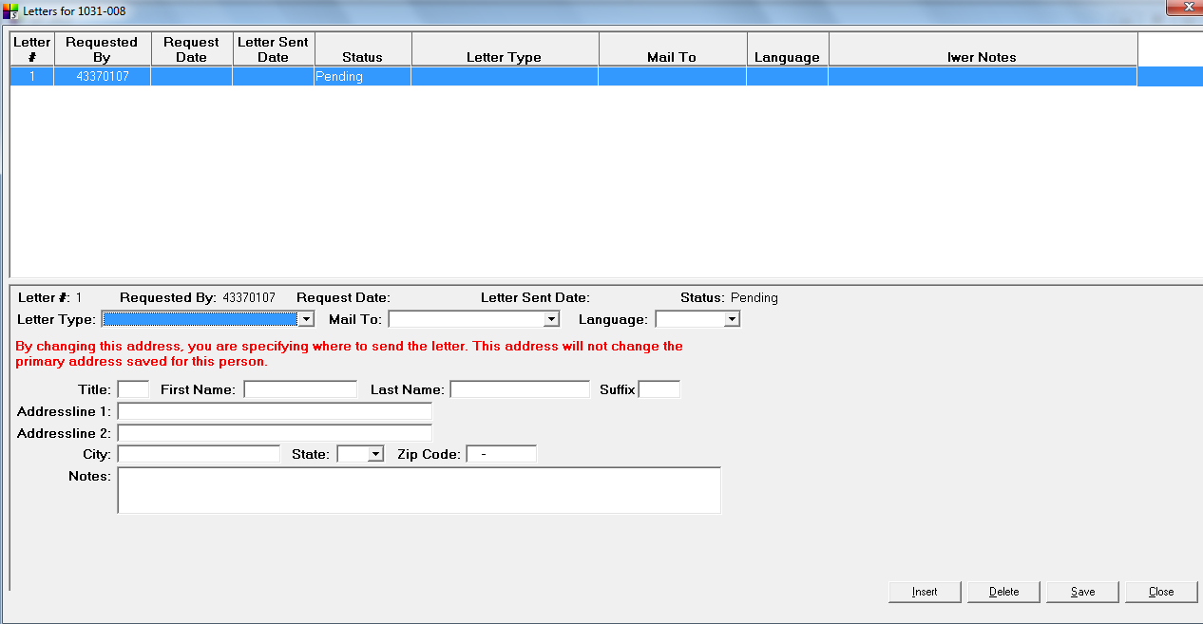
Top Pane

Column Heading |  SurveyTrak DB Column | Notes
Letter # | tletters.sletterid
Requested By | tletters.sintervieweremployeeid
Request Date | tletters.drequestdate
Letter Sent Date | tletters.ddatelettersent
Status | tletters.stier2status | Display only  1=Approved  2=Not Approved  3=Pending  4=Need More Info
Letter Type | tletters.stypeofletter | 1=Not Interested/Evasive  3=Privacy  4=Too Busy  5=Not at Home  O=Other (enter in Notes field)
Mail To | tletters.smailto | C1=Contact 1  C2=Contact 2  O=Other  R=Respondent
Language | tletters.slanguage | E=English  S=Spanish
Iwer Notes | tletters.lviwernotes

Bottom Pane

Row | Label |  SurveyTrak DB Column | Notes
1 | Letter # | tletters.sletterid | Display only
1 | Requested By | tletters.sintervieweremployeeid | Display only
1 | Request Date | tletters.drequestdate | Display only
1 | Letter Sent Date | tletters.ddatelettersent | Display only
1 | Status | tletters.stier2status | Display only. Values:  1=Sent  2=Not Approved  3=Pending
2 | Letter Type | tletters.stypeofletter | 1=Not Interested/Evasive  3=Privacy  4=Too Busy  5=Not at Home  O=Other (enter in Notes field)
2 | Mail To | tletters.smailto | C1=Contact 1  C2=Contact 2  O=Other  R=Respondent
2 | Language | tletters.slanguage | E=English  S=Spanish
3 | (interviewer instructions) | By changing this address, you are specifying where to send the check or money order. This address will not change the primary address save for this person.
4 | Title | tletters.stitle_long
4 | First Name | tletters.vfirstname
4 | Last Name | tletters.vlastname
4 | Suffix | tletters.ssuffix
5 | Addressline1 | tletters.vaddressline1
6 | Addressline2 | tletters.vaddressline2
7 | City | tletters.vcity
7 | State | tletters.sstate
7 | Zip Code | tletters.spostalcode
8 | Notes | tletters.lviwernotes

Line Spawning
This project will not need to create additional sample lines on the laptop.

Locating
This project will not need to display address updates from Web Logging for Locating.

Payments
This project will have the Payments module.
All fields are required by the payment system, but the options displayed can be customized to a certain extent.
All interviewer requested checks and money orders are subject to WebTrak approval by a project-authorized person
Only payments requested by the interviewer are editable by the interviewer.
Interviewer can edit any fields of the payment requests prior to send/receive (with the exception of the amount for wizard-driven payments).
Address changes on payment screens are not written back to tSample_Line_Address.

Wizard Driven Payments
There will be a Payment screen in the Call Wizard.
 Please choose one of the following three options. The first option is the default option unless otherwise specified.
- The Wizard is displayed and the wizard payment is set to approved unless there are pre-existing payments, in which case the wizard payment is set to pending.
- The Wizard is displayed and the wizard payment is automatically set to approved even if there are pre-existing payments.
- The Wizard is displayed and the wizard payment is set to approved unless there are pre-existing payments, in which case the wizard is skipped and no wizard payment is created. This option requires an project-specific programming (approximately 2-4 hours).
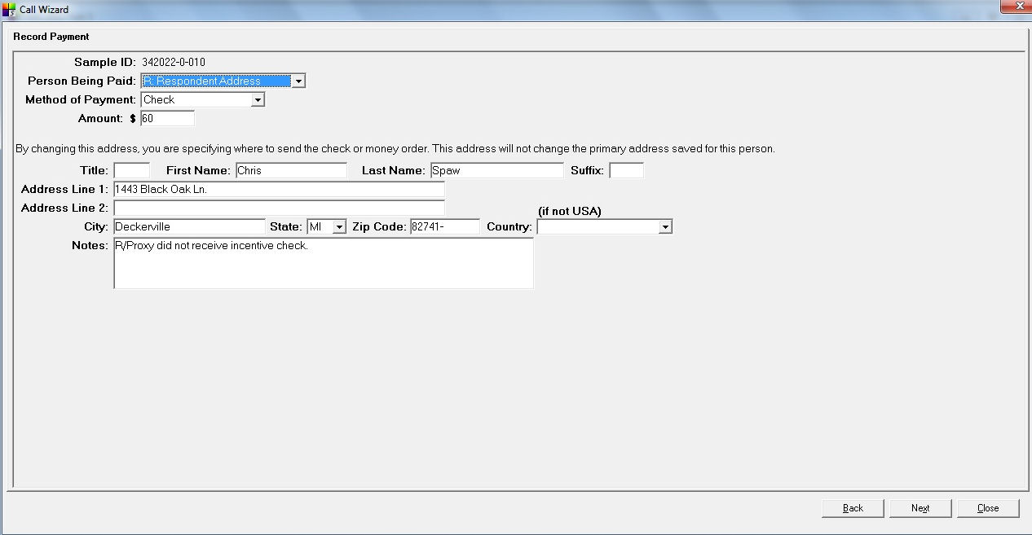

Label |  SurveyTrak DB Column | Notes
Sample Line | trpay.vamplelineid
Person Being Paid | trpay.spersontype | O=Other  R=Respondent
Method of Payment | trpay.spaymode | 1=Check  2=Cash  3=Money Order  4=Refused Payment
Amount | trpay.npayamount | Display only.  $25
(interviewer instructions) | By changing this address, you are specifying where to send the check or money order. This address will not change the primary address save for this person.
Title | trpay.stitle_long
First Name | trpay.vfirstname
Last Name | trpay.vlastname
Suffix | trpay.ssuffix
Address Line 1 | trpay.vaddressline1
Address Line 2 | trpay.vaddressline2
City | trpay.vcity
State | trpay.sstate
Zip | trpay.spostalcode
Interviewer Requested (Edit -> Payments)
Interviewers can request payments through the Payment module.

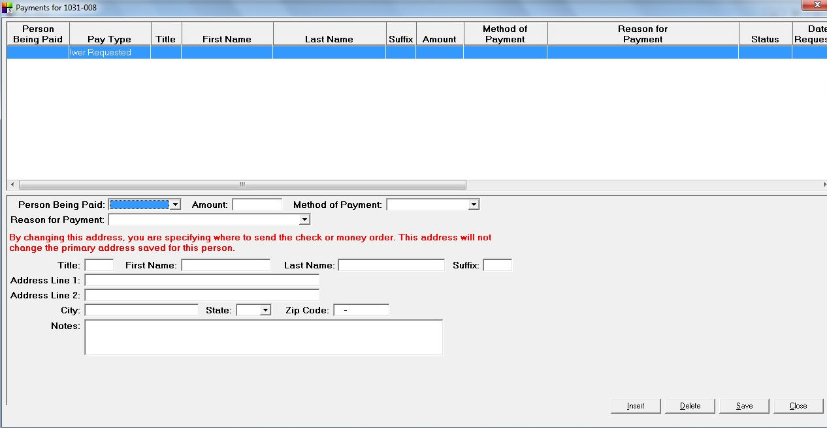

Top Pane

Column Heading |  SurveyTrak DB Column | Notes
Person Being Paid | trpay.spersontype | C1=Contact 1  O=Other  R=Respondent
Pay Type | trpay.spaytrigger | C=Completed IW  I=Iwer Requested  D=Other  M=WebTrak
Title | trpay.stitle_long
First Name | trpay.vfirstname
Last Name | trpay.vlastname
Suffix | trpay.ssuffix
Amount | trpay.npayamount
Method of Payment | trpay.spaymode | 1=Check  2=Cash  3=Money Order  4=Refused Payment
Reason for Payment | trpay.spayprobcode | 1=Additional payment  2=Additional payment promised but not received  3=Not paid in previous wave(s)  4=Last check expired  5=Could not cash a check  O=Other (enter in Notes field)
Status | trpay.spayapprove | 1=Yes  2=No  3=Pending  4=N/A
Date Requested | trpay.dpayrequestdate
Date Approved | trpay.dpayapproved
Date Processed | trpay.dpayprocessdate
Date Check Issued | trpay.ddatecheckissued
Check Number | trpay.scheckno
Disposition | trpay.sreconciliationcode | R=Cashed  C=Voided
Disposition Date | trpay.dreconciliationdate
Notes | trpay.lvpayproblemdesc

Bottom Pane

Row | Label |  SurveyTrak DB Column | Notes
1 | Person Being Paid | trpay.spersontype | C1=Contact 1  O=Other  R=Respondent
1 | Amount | trpay.npayamount | Range of $1 to $1000
1 | Method of Payment | trpay.spaymode | 1=Check  2=Cash  3=Money Order  4=Refused Payment
2 | Reason for Payment | trpay.spayprobcode | 1=Additional payment  2=Additional payment promised but not received  3=Not paid in previous wave(s)  4=Last check expired  5=Could not cash a check  O=Other (enter in Notes field)
3 | (interviewer instructions) | By changing this address, you are specifying where to send the check or money order. This address will not change the primary address save for this person.
4 | Title | trpay.stitle_long
4 | First Name | trpay.vfirstname
4 | Last Name | trpay.vlastname
4 | Suffix | trpay.ssuffix
5 | Address Line 1 | trpay.vaddressline1
6 | Address Line 2 | trpay.vaddressline2
7 | City | trpay.vcity
7 | State | trpay.sstate
7 | Zip | trpay.spostalcode
8 | Notes | trpay.lvpayproblemdesc | Becomes required if Reason for Payment is Other.

RCLS (Respondent Contact Logging System)
This project will use RCLS.

Reason for Transfer
This project will use the Reason for Transfer feature to allow interviewers to indicate why they are transferring sample to another interviewer.
- The reasons for transfer are displayed alphabetically by the text description, not by the code value. This cannot be changed.
- Code values must be in the same order as the text description in order for the reasons to display properly in WebTrak. This cannot be changed.
The reasons for transfer are listed below.
1=Appt made outside Iwer working schedule
2=Iwer busy with other appts
3=Iwer leaving project
4=Iwer on vacation
5=Iwer sick
6=Locating needed
7=Mode change needed
8=Other (please specify)
9=Refusal conversion needed
10=Spanish-speaking iwer needed
11=Technical/procedural problem
12=Trying new voice/caller id

Related Case Details
This project will not use Related Case Details.

Respondent Profiles
This project will not use Respondent Profiles.

TL Approval
This project will use the TL Approval module. Requests are made by the interviewer in SurveyTrak and approved by the TL’s and PC’s in WebTrak.

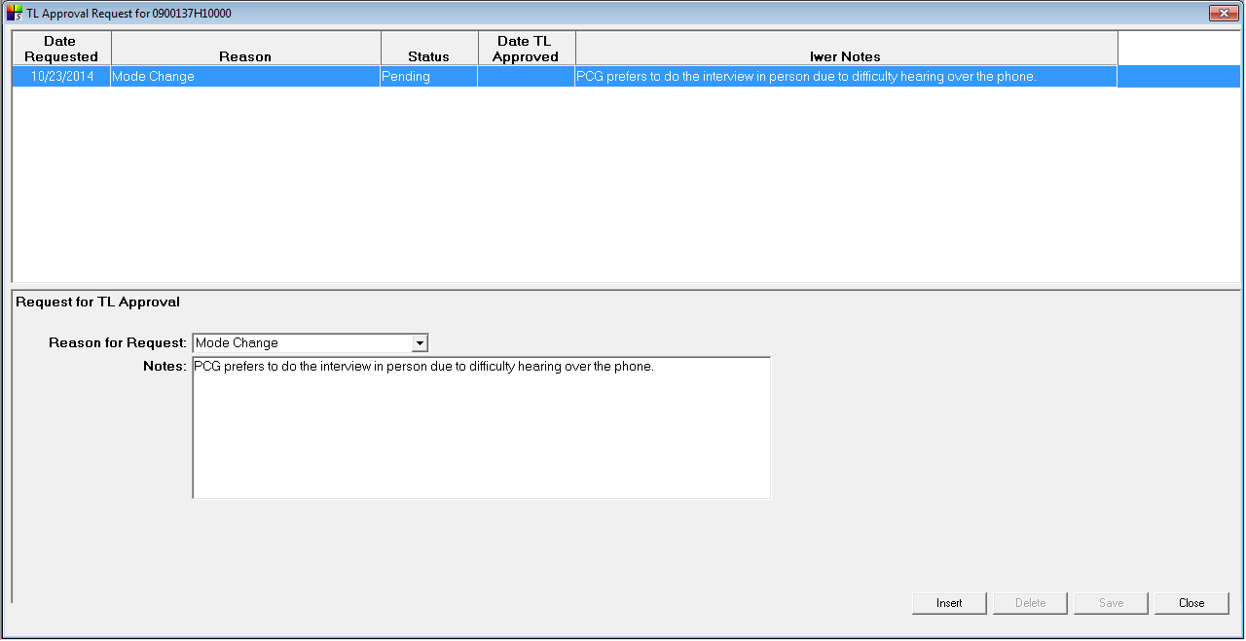
The reasons for TL Approval are:
1 = Locked Building Procedures
2 = Paper Screener

Top Pane

Column Heading |  SurveyTrak DB Column | Notes
Date Requested | tsample_line_supplemental.dtdatetime1
Reason | tsample_line_supplemental.iseq
Status | tsample_line_supplemental.nnum2
Date TL Approved | tsample_line_supplemental.dtdatetime2
Iwer Notes | tsample_line_supplemental.vstr1

Bottom Pane

Column Heading |  SurveyTrak DB Column | Notes
Reason for Request | tsample_line_supplemental.iseq
Notes | tsample_line_supplemental.vstr1

Verification
This project will conduct verification of interviews in the SSL. Variables to pull from the interview into the SurveyTrak database are as follows:

Instrument Field Name |  SurveyTrak DB Column | Notes
 | tsample_line.vmsmsverificationq01
 | tsample_line.vmsmsverificationq02

Result Codes
The current master list of valid result codes is available on the SRO intranet. See the Master Result Codes link on the Data Collection tab or the Technical Services tab.
Please note that result code descriptions cannot exceed 50 characters.
See also the Post-Disposition Actions section.

Result  Code | Description | Result Type | Report  Column | Modes  1=TEL  2=FTF  3=Email  4=Admin  5=Mail  6=Text  7=Video | Obs Call Modes
0000 | Not Worked |  | NOATM
1001 | Complete Interview | CO,FI,IW | IWSALL,IWSCOM | 1,2,7 | 1,2,7
1005 | Partial Complete | IW,FI,CO,PR | IWSALL,IWSPTL | 1,2,7 | 1,2,7
1401 | Answering Machine/Service Reached, No Message Left | NC | NOCON | 1
1402 | Answering Machine/Service Reached, Message Left | NC | NOCON | 1
2005 | Respondent Not at Address (FTF only) | NC | NOCON | 2
2006 | Bad Address/Address Non-Existent | NC | NOCON | 2,3,5,6
3001 | No One Home/Email Sent/Ring No Answer | NC | NOCON | 2,3,5,6,7
3003 | No Contact -- Locked Building/Gated Community | NC | NOCON | 2
4001 | Contact No Resistance, General Callback, Informant | CO,CB | CONALL,CONNORSI | 1,2,3,5,6,7 | 1,2,3,5,6,7
4201 | Contact No Resistance, Appointment Made, Informant | CO,AP,CB | APTALL,CONALL,HRDAPT | 1,2,3,5,6,7 | 1,2,3,5,6,7
4301 | Contact Initial Refusal, Informant | CO,RE,CB | CONALL,CONRSI | 1,2,3 | 1,2,3
4901 | Hold, Technical Problem | HO | HLDALL,TECHLD | 1,2,3,4,5,6,7
4902 | Hold, Procedural Problem | HO | HLDALL,PROHLD | 1,2,3,4,5,6,7
5001 | Final Refusal, Respondent | CO,RE,FR,FI | NIREF | 1,2,3,4,5,6,7 | 1,2,3,5,6,7
6005 | NI, Language Barrier | CO,FI,NI | OTHNI | 1,2,3,4,5,6,7 | 1,2,3,5,6,7
6007 | NI, Other Reason | CO,FI,NI | OTHNI | 1,2,3,4,5,6,7 | 1,2,3,5,6,7
7001 | NS, House Vacant (FTF) | FI,NS | NSOTH | 2,4
7003 | NS, Occupants Currently Reside Elsewhere | FI,NS | NSOTH | 1,2,3,4,5,6,7
8011 | NS, Deceased Respondent | FI,NS | NSALL | 1,2,3,4,5,6,7

Result Types
The following result types are used in reports.
Code | Description
AP | Appointment
CB | Callback
CO | Contact
EL | Eligible
FI | Final
FR | Final Resistance
HO | Hold
IW | Interview
NC | No Contact
NI | Non-interview
NS | Non-sample
PR | Partial Interview
RE | Resistance
TR | Locating

Result Flags
The following flags are set to true at the first occurrence of specified result type. They are only set once, they are never reset.

Flag | Result Type | SurveyTrak DB Column
Appointment Flag | AP | tsample_line.blapptflag
Contact Flag | CO | tsample_line.blcontactflag
Respondent Concerns Indicator Flag | RE, FR | tsample_line.blrcindflag
Locating Flag | TR | tsample_line.bltrackflag

