ET Supervisor Guide

Welcome to the ET timesheet system. You will login using your UM Kerberos credentials. Here’s the URL for the
Web ET: https://timesheet.isr.umich.edu

Supervisors will see this homepage. You can access timesheets and your team members from this page. Also, timesheets awaiting your approval. To search for an employee, type their name in the search bar and click Enter.
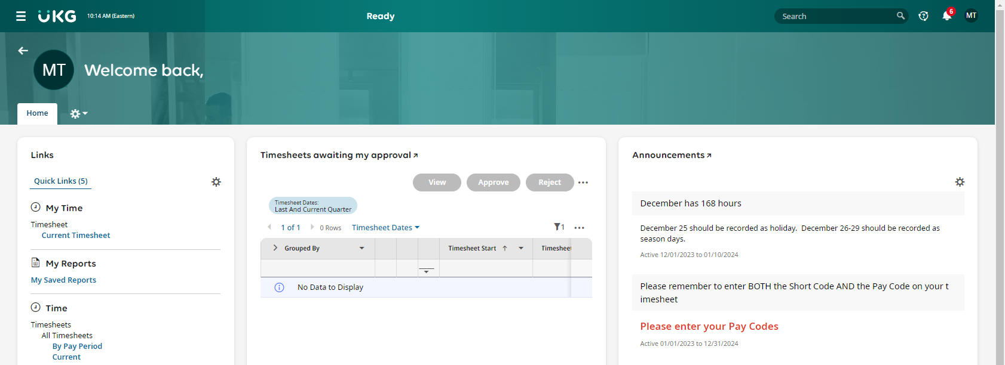

Click on the UKG logo at any time to return to your homepage.

Timesheets Awaiting Approval

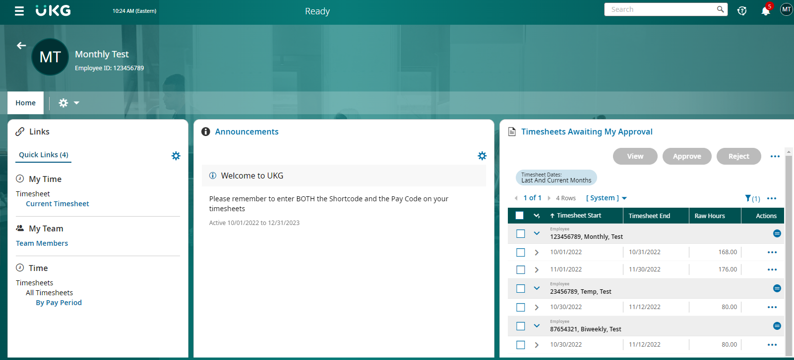
You can click the Select All box and View to review these.

Use the arrows to navigate between timesheets. Pay period. Status. Total hours. Approve or Reject.

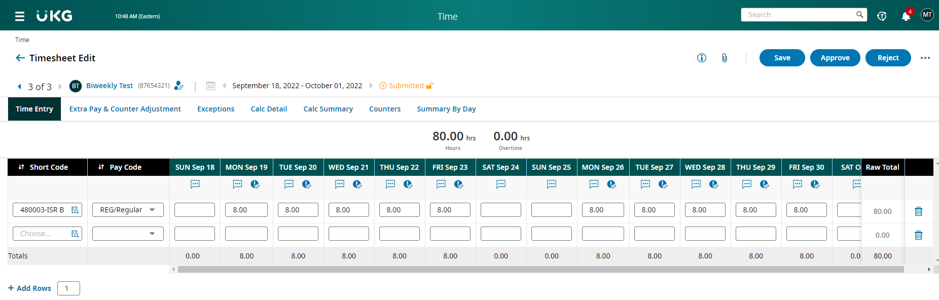
You can also see the total hours at the top of the timesheet.

Please double-check both the Short Code and the Pay Code. Both Short Code and Pay Code must be completed.

Searching for a Timesheet

To search for a timesheet, either click on Timesheets by Pay Period on your home page or go to the Hamburger Menu in the upper left corner of the page.

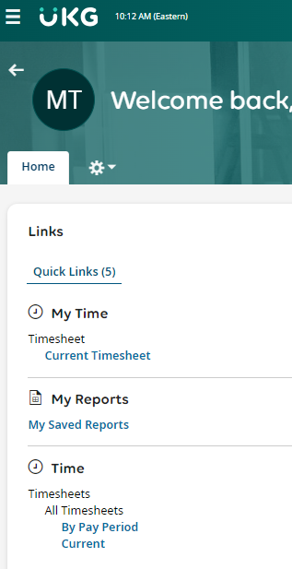

If you click on the Hamburger menu, you will see the following:
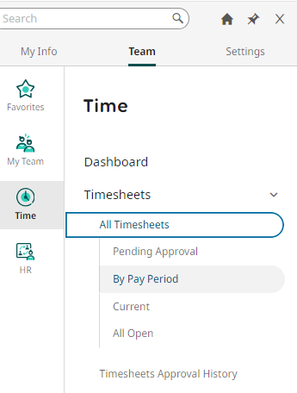

The My Info is your information – your timesheet, reports, etc. Team is your team information and timesheets. Settings is not relevant to us. Clicking on Time will take you to the options for viewing your team’s timesheets.
Use the Timesheets By Pay Period report to search for individual timesheets, to find outstanding timesheets in need of completion or approval and to review all of the timesheets for a specific employee group.

Finding Outstanding Timesheets
Use the Timesheets By Pay Period report as shown above.
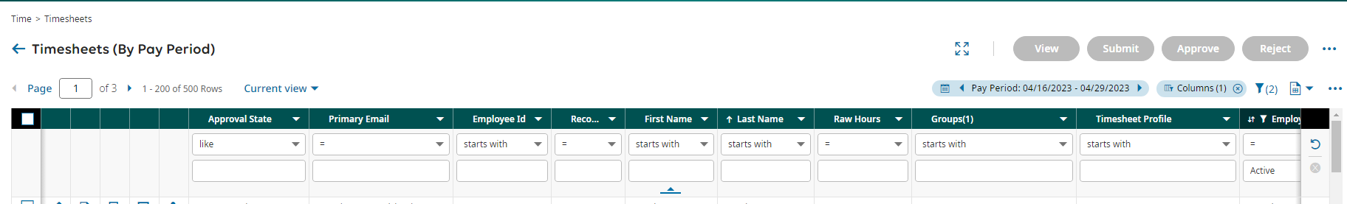
Make sure that your pay period is the one that you want to view.
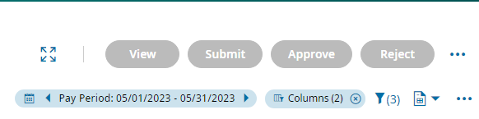
To change the pay period, click on the Filter icon.
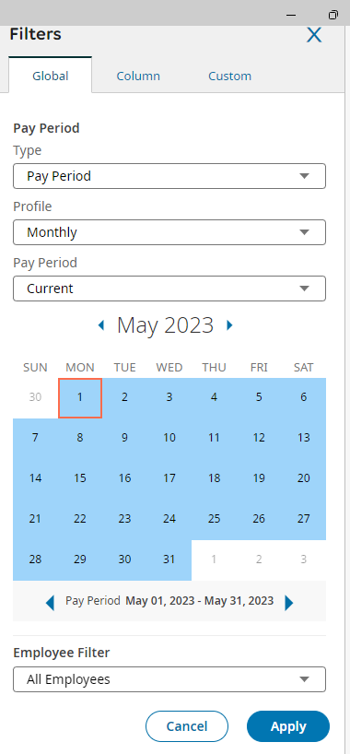
Use the drop down arrows to choose between a variety of options including Monthly or Biweekly, Pay Period or Date Range, Current or Previous plus many others.
Click Apply when you have finished making your selections.

To find timesheets that need to be completed, filter Approval State, like, open. For timesheets that need to be approved, filter Approval State, like, submitted.
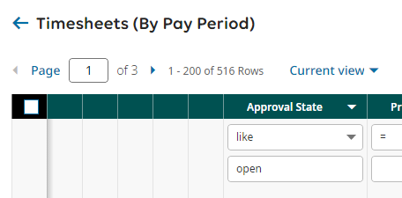

You can also filter by emplid, First Name, Last Name or your group name.
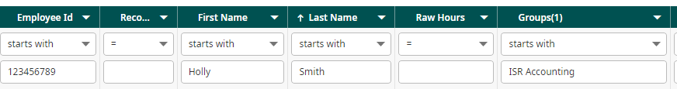

You can filter by type of employee. Temporary, Time and a Half Eligible (regular biweekly) or exempt (monthly).
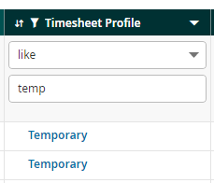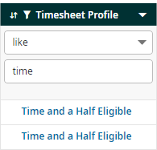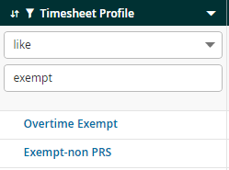
Make sure to hit Enter after choosing your filters to refresh the data.

You can sort by Last Name, First Name etc. by clicking on the area to the right of each header to bring up the sort arrows.
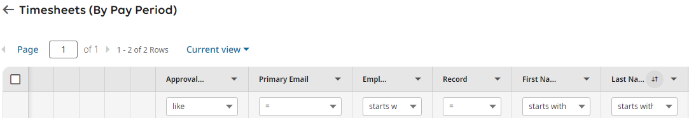

Bringing up all the timesheets for an individual employee

Clicking on My Team will take you to options for viewing your team members.
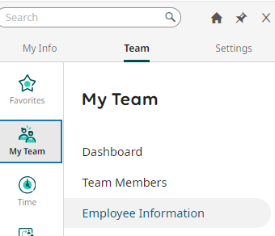

Click on Employee Information to go to a list of your employees. Click on Employee Quick Links and Actions icon to bring up your options. Choose All Timesheets to bring up the employee’s past and current timesheets.
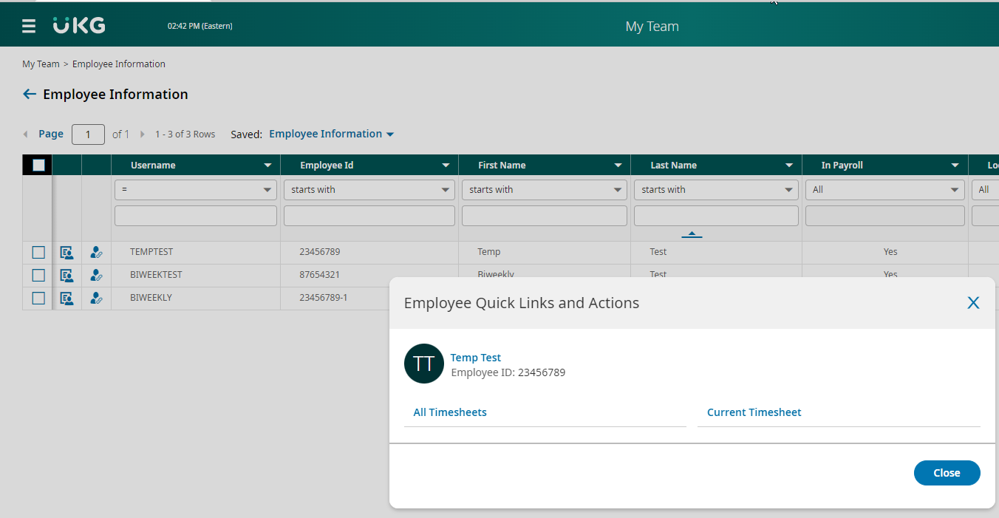

Click on the boxes to the left of the employees to select all or individuals. Click on View to review timesheets.

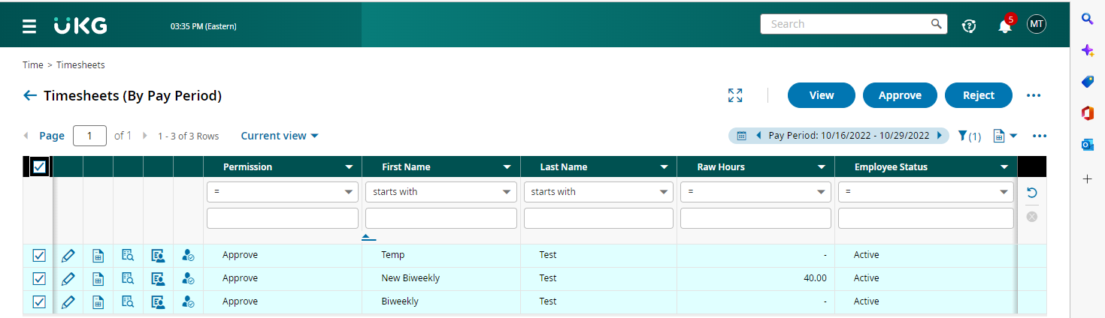

When viewing the timesheet list, you can move from one pay period to the next by using the arrows. Or you can use the filter.

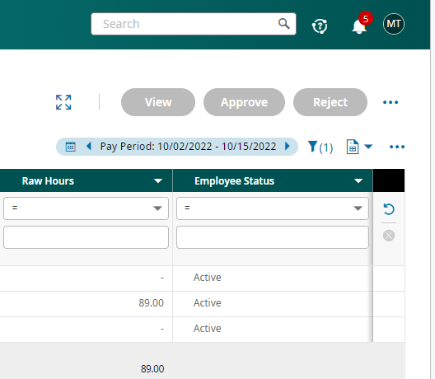

Prior Period Timesheet Corrections
Employees can make changes to their timesheets for any pay period that is open. Pay periods that are more than 120 days old are closed and timesheets cannot be changed. Supervisors who want to make changes to an employee’s timesheet must first reject it by clicking the Reject button.
After any changes are made, the timesheet must be submitted and approved in order for the changes to be processed.

You can review the changes made to your employee’s timesheet by clicking on the three dots on the upper right of the timesheet and clicking Timesheet Audit Trail.
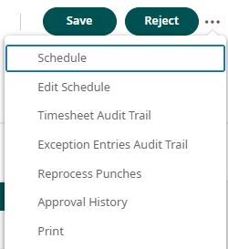

Using the same drop down, you can review the Approval History and Print the timesheet.
Using Timesheet Audit trail

You can review the original timesheet entries and the changes that were made.

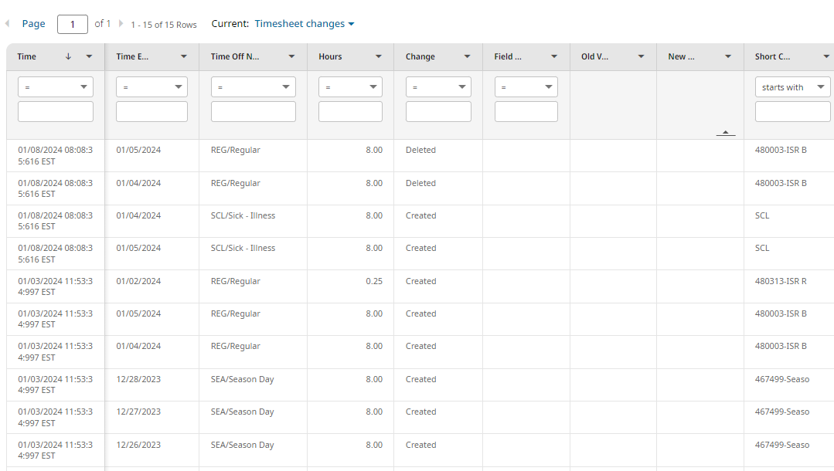

To make it easier to see what has been changed, filter the date by making it one day greater than the date that they originally filled out the timesheet.
As you can see, this employee deleted the REG time that they had originally recorded on 1/4/24 and 1/5/24 and replaced it with SCL/Sick time for those days.
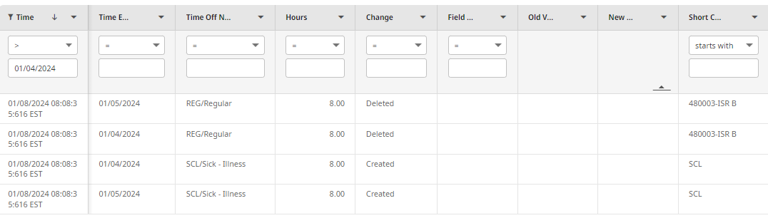

You can also sort by short code, time off, date, etc. by clicking on the area to the right of each header to bring up the sort arrows.

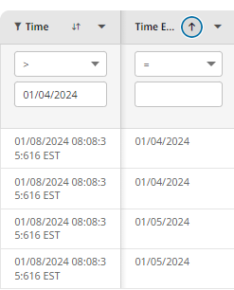

Reviewing Approval History
You can review a timesheet’s approval history by clicking Approval History.

This will show the timesheet’s history including when it was submitted and approved. If the timesheet has been reopened for corrections, that will also be included.
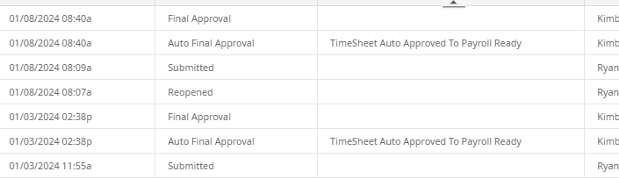

Reporting

Click on the hamburger menu. Then click on My Info. Click on Report Hub for an extensive list of available reports. Many of these will not be helpful for ISR purposes.
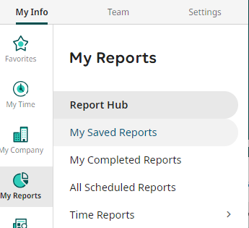

Click on My Saved Reports to see reports that have been created for ISR.
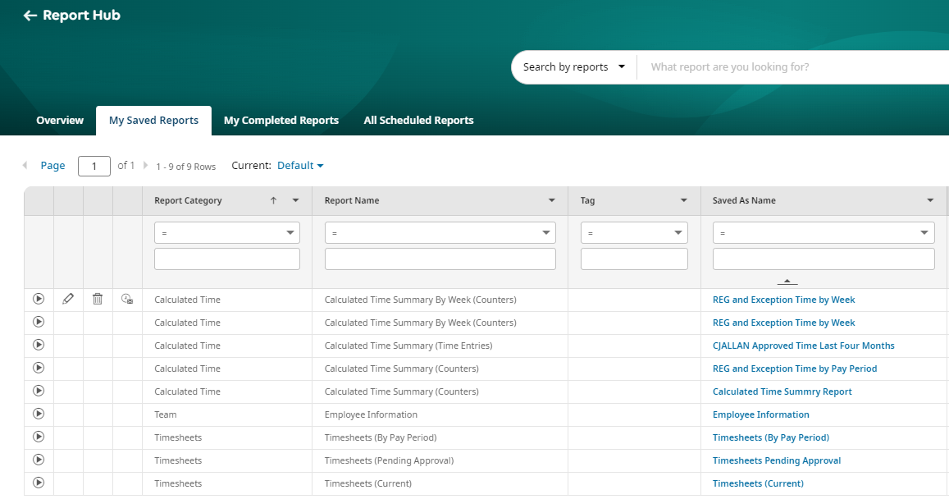

Click on either the arrow or the name of the report to run it.

