How to decrease/increase the size of the button in Excel sheets:

Here is an example how the buttons in the Excel Sheets increase/decrease over time.

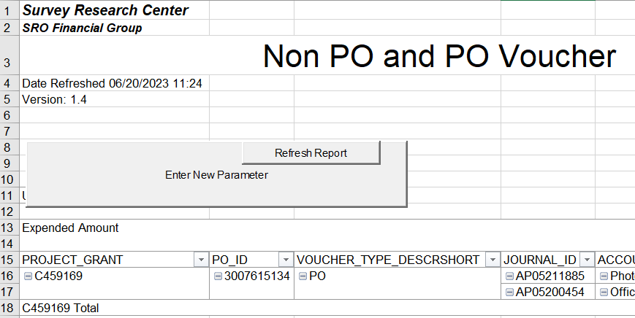
In order to resolve this:
Step 1: Click on “Developer” Tab and then click-on “Design Mode”
Note if you do not see the Developer tab
On the File tab, go to Options > Customize Ribbon.
Under Customize the Ribbon and under Main Tabs, select the Developer check box.

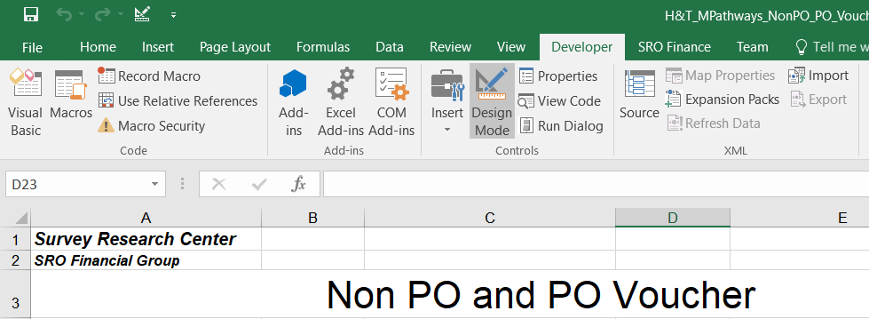

Step 2: Once the excel sheet in design mode then single-click on the button. Then you see like this
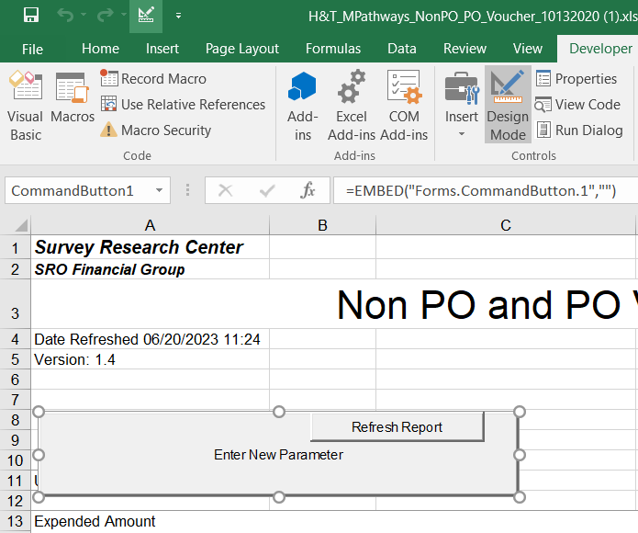

Step 3: Use the mouse to minimize the button size
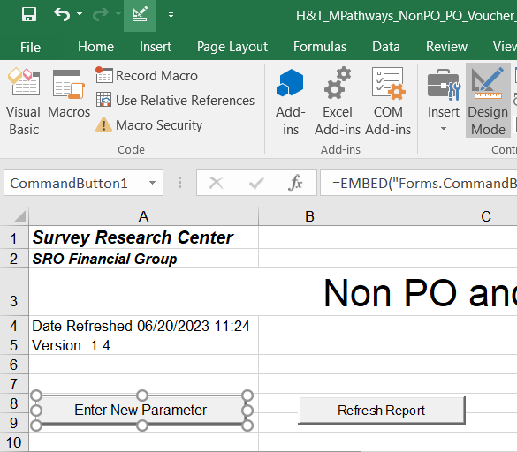

Step 4: Once the re-size the excel button is done. Click on the Design-Mode again to go to real excel file how it was.

