SurveyTrak International Specification Model
Updated 15 August 2022

Table of Contents
Table of Contents 1
Record of Edits 3
Overview 4
General Project Information 4
Projects 4
Instruments 4
Main Instrument 4
Observations Instrument 4
Checklist of SurveyTrak Features 5
Pre-Load 5
SurveyTrak Data Preload 5
Blaise Main Preload 5
Blaise Observations Preload 5
Blaise Data Pulls 6
Main Instrument 6
Observations Instrument 6
Suspended Variable 6
SurveyTrak Features/Modules 6
Standard SurveyTrak Tabs 6
Sample Tab 6
Address Tab 8
Transfer History Tab 9
Finalized Tab 9
View/Edit Tabs & Windows 9
Tab Order 9
Call Info Tab 9
Address Tabs Specifications 9
Respondent Address Tab 10
Contact Address Tab 11
All Notes 12
Call Wizard 13
Call Info Window 13
Pre-Disposition Actions 14
Post-Disposition Actions 14
Change Language 15
Export/Import Sample 15
Export Window 15
Import Window 15
Laptop Reports 15
Line Spawning 15
Related Case Details 15
Result Codes 16
Result Types 16
Result Flags 17

Record of Edits
Date | Name | Notes

Overview
About This Document
Information in this document is displayed in multiple formats (tables, images, narrative) whenever possible. Since most images are based on screen shots from existing SurveyTrak projects, there may be inconsistencies between what an image displays and what a table specifies. In these cases the table information should be considered more accurate.

Norms
Code vs. label: When we have the option of either storing a code (numeric value) or a label (text) we will store the code and display the label. For example, 1=Yes, 0=No – We will store either 1 or 0 in the tables and display Yes or No in the application. One exception is result codes – we store AND display the code.
Formatted data (masks): Formatting for dates and telephone numbers are as follows:
  - Dates: dd/mm/yyyy
  - Telephone numbers: (###) ###-####

Legend
The following symbols are used in this document:
 Indicates that the feature is “locked” and cannot be customized.
 Indicates a customizable feature that is typically customized for each project. Please pay particular attention to these sections.

 Indicates that the information will be provided by the Technical Services Group (TSG).

General Project Information
Projects
Projects | Sample ID Format |  Project ID
Pretest | xxxx-xxx | SRC.SRO.DEMO.PRETEST
Training | xxxx-xxx | SRC.SRO.DEMO.TRAIN
Certification | xxxx-xxx | SRC.SRO.DEMO.CERT
Production | xxxx-xxx | SRC.SRO.DEMO.PROD

Instruments
Main Instrument
Instrument Type | Required for this project?
Blaise Screener | No
Blaise Main | Yes
Observations Instrument
Instrument Type | Required for this project?
Blaise Contact Obs | Yes
Blaise Post-Interview Obs | No
SurveyTrak Housing Unit Obs | No

Checklist of SurveyTrak Features
Feature/Module | Required for Pretest? | Required for Training? | Required for Production?
SurveyTrak Pre-Load and Post-Load
Main Instrument Preload | Yes | Yes | Yes
Data Pulls from Main Instrument | Yes | Yes | Yes
Observations Instrument(s) Preload | Yes | Yes | Yes
Data Pulls from Observations Instrument(s) | Yes | Yes | Yes
SurveyTrak
Change Language | Yes | Yes | Yes
Export/Import Sample (Offline Transfer) | Yes | Yes | Yes
Laptop Reports | No | No | No
Line Spawning | No | No | No
Related Case Details | No | No | No

Pre-Load
SurveyTrak Data Preload
The SurveyTrak preload is documented in the following location:
Blaise Main Preload
The Blaise instrument preload is documented in the following location:
Blaise Observations Preload
Observations preload is created dynamically by SurveyTrak when launching the Observations instrument. The base preload format is as follows:

 | Position | Field Name |  SurveyTrak DB Column
 | 1 | SampleID | tsample_line.vsamplelineid
 | 2 | CallNum | tcallinformation.ncallinfoid
 | 3 | ResultCode | tsample_line.sresultcode
 | 4 | IW_InstID | tsample_line.siwinstid
 | 5 | S_attr1 | tsample_line.ssampletype1
 | 6 | S_attr2 | tsample_line.ssampletype2
 | 7 | S_attr3 | tsample_line.ssampletype3
 | 8 | S_attr4 | tsample_line.ssampletype4
 | 9 | FirstCon | (calculated based on all existing calls)
 | 10 | FirstRef | (empty)
 | 11 | Mode | tsample_line.slastcallmode
 | 12 | HH_Screened | tsample_line.bhh_screen
 | 13 | Call_Result_Date | tsample_line.dresultdate
Additional preload is not required for this project.

Blaise Data Pulls
This project will need interview data to be pulled into SurveyTrak from both the Main Instrument and the Observations Instrument (“BCP Pull”).
Main Instrument
Instrument Field Name | Blaise Codeframe |  SurveyTrak DB Column | SurveyTrak Display
Section_D.D5 | 1=Yes, 5=No | tsample_line.vext_025 | n/a
Section_G.G2 | 1=Rent, 2=Own, 3=Neither | tsample_line.vext_026 | n/a
Observations Instrument
Data pulled from the Observations instrument is displayed in the All Notes window.

Instrument Field Name |  SurveyTrak DB Column
RComm_Time | tcallinformation.blobs_time
RComm_Interest | tcallinformation.blobs_interest
RComm_Confidential | tcallinformation.blobs_confidential
RComm_Sensitive | tcallinformation.blobs_sensitive
RComm_Purpose | tcallinformation.blobs_purpose
RComm_Govt | tcallinformation.blobs_govt
RComm_WhyMe | tcallinformation.blobs_whyme
RComm_Voluntary | tcallinformation.blobs_voluntary
RComm_Incentive | tcallinformation.blobs_incentive
RComm_None | tcallinformation.blobs_none
RComm_Other | tcallinformation.blobs_other
RComm_Spec | tcallinformation.vobs_otherspecify
RQuestions | tcallinformation.blobs_questions
TotalMins | tcallinformation.ncontobstime

Suspended Variable
When suspending Blaise, this project should also pull the Blaise variable CurrentFieldName from Blaise into:
- tsample_line.viwsupendvariable
- tcallinformation.viwsuspendvariable
- Also set tcallinformation.bliw_suspended to 1.

SurveyTrak Features/Modules
Standard SurveyTrak Tabs
Sample Tab
The Sample tab displays non-finalized lines. Lines will move to the Finalized tab once a call record with a final result code is entered. If a line is finalized but the observations are not complete, the line will stay on the Sample tab until observations are completed.
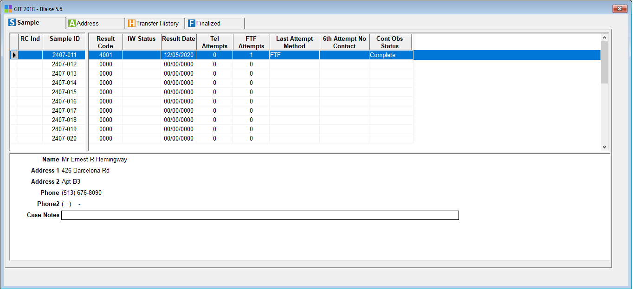

Top Pane
Column Heading |  SurveyTrak DB Column | Notes
RC Ind | tsample_line.blrcindflag | LOCK column
Sample ID | tsample_line.vsamplelineid | LOCK column; default sort
Result Code | tsample_line.sresultcodeid
IW Status | tsample_line.siwinststatus | 0=Complete, 1=Suspend, 2=Problem
Result Date | tsample_line.dresultdate
Tel Attempts | tsample_line.sitelcalls
FTF Attempts | tsample_line.sifacetoface
Last Attempt Method | tsample_line.slastcallmode | 1=TEL, 2=FTF, 3=Email, 4=Admin, 5=Mail, 6=Text, 7=Video
6th Attempt No Contact | tsample_line.inocontactcount
Wizard Actions | tsample_line.vwizardactionflags
Cont Obs Status | tsample_line.scon_obs_sum_status | 0=Complete, 1=Suspend, 2=Problem, 3=Incomplete
Iwer Obs Status | tsample_line.spio_status | 0=Complete, 1=Suspend, 2=Problem, 3=Incomplete

Bottom Pane
Label |  SurveyTrak DB Column | Notes
Name
Address 1 | tsample_line_address.vaddressline1
Address 2 | tsample_line_address.vaddressline2
Phone | tsample_line_address.sphone
Phone 2 | tsample_line_address.sphone2
Case Notes | tsample_line.lvcasenotes

Address Tab
The Address tab displays the same lines as the Sample tab.
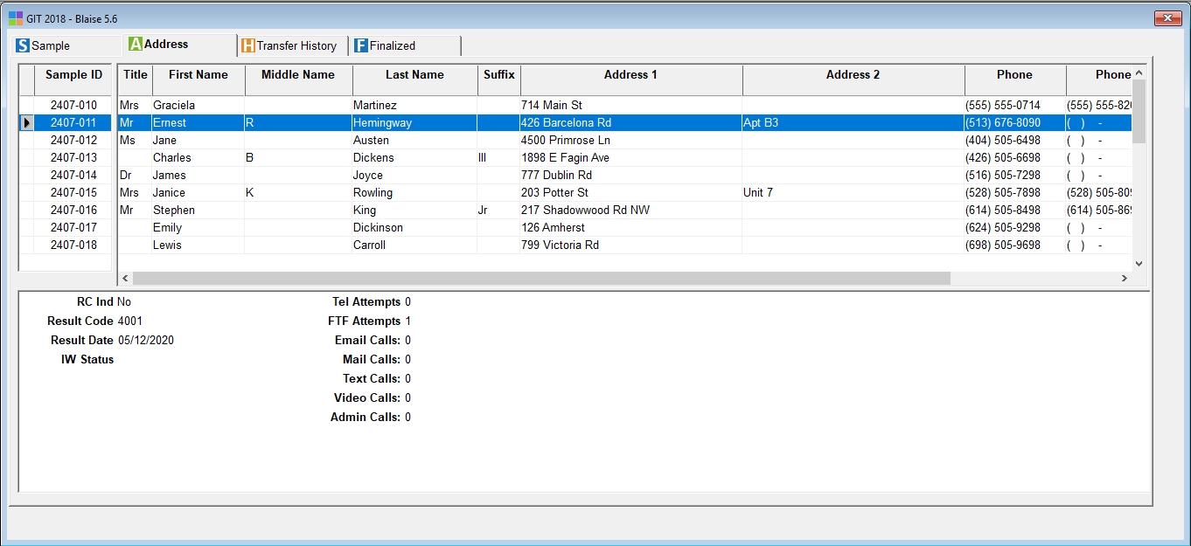

Top Pane
Column Heading |  SurveyTrak DB Column | Notes
Sample ID | tsample_line.vsamplelineid | LOCK column; default sort
Title | tsample_line_address.stitle
First Name | tsample_line_address.vfirstname
Middle Name | tsample_line_address.vmiddlename
Last Name | tsample_line_address.vlastname
Suffix | tsample_line_address.ssuffix
Address 1 | tsample_line_address.vaddressline1
Address 2 | tsample_line_address.vaddressline2
Phone | tsample_line_address.sphone
Phone2 | tsample_line_address.sphone2
Email Address | tsample_line_address.vemail

Bottom Pane
Column | Label |  SurveyTrak DB Column | Notes
1 | IW Status | tsample_line.siwinststatus
1 | Result Code | tsample_line.sresultcodeid
1 | Result Date | tsample_line.dresultdate
2 | RC Ind | tsample_line.blrcindflag
2 | Tel Attempts | tsample_line.sitelcalls
2 | FTF Attempts | tsample_line.sifacetoface
2 | Email Attempts | tsample_line.siemailcalls
2 | Mail Attempts | tsample_line.simailcalls
2 | Text Attempts | tsample_line.sitextcalls
2 | Video Attempts | tsample_line.sivideocalls
2 | Admin Attempts | tsample_line.siadmincalls

Transfer History Tab
Column Heading |  SurveyTrak DB Column | Notes
Sample ID | tsample_line.vsamplelineid
Transfer Date and Time | ttransferhistory.tstransferdate
Sending Interviewer | tsample_line.siwersubscribeid
Receiving Interviewer | tsample_line.stransferiwer
Transfer Type

Finalized Tab
The Finalized tab displays lines where a call record with a final result code has been entered. If the call record required observations but the observations were not completed, the line stays on the Sample tab until the observations are complete.
 The Top and Bottom panes of the Finalized tab are the same as the Sample tab. Please see Sample Tab the section.

View/Edit Tabs & Windows
Tab Order
 From left to right:
- Call Info
- Respondent Address
- Contact Address

Call Info Tab
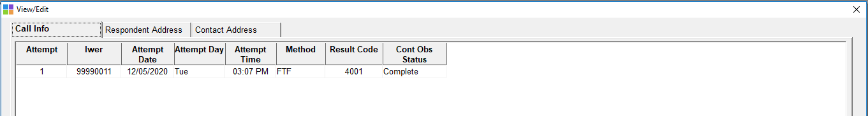

Information from the Call Info tab comes from the top pane of the Call Info window. Please note that Call Info is view-only here.
Address Tabs Specifications
In the address tabs below:
- Code frame for phone types: 1=Home, 2=Work, 3=Mobile, 4=Pager, 5=Fax

Respondent Address Tab
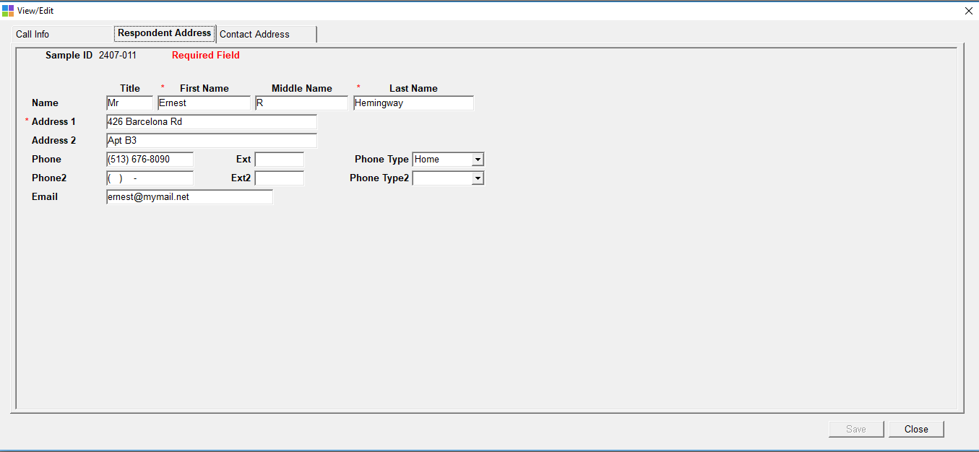

 The person type is R.
The fields to be displayed are:

Label  * = required field |  SurveyTrak DB Column | Notes
Sample ID | tsample_line_address.vsamplelineid
Title | tsample_line_address.stitle
*First Name | tsample_line_address.vfirstname
Middle Name | tsample_line_address.vmiddlename
*Last Name | tsample_line_address.vlastname
*Address 1 | tsample_line_address.vaddressline1
Address 2 | tsample_line_address.vaddressline2
Phone | tsample_line_address.sphone
Ext | tsample_line_address.sphoneextension
Phone Type | tsample_line_address.sphonetype1
Phone2 | tsample_line_address.sphone2
Ext2 | tsample_line_address.sphone2extension
Phone Type2 | tsample_line_address.sphonetype2
Email | tsample_line_address.vemail

Contact Address Tab
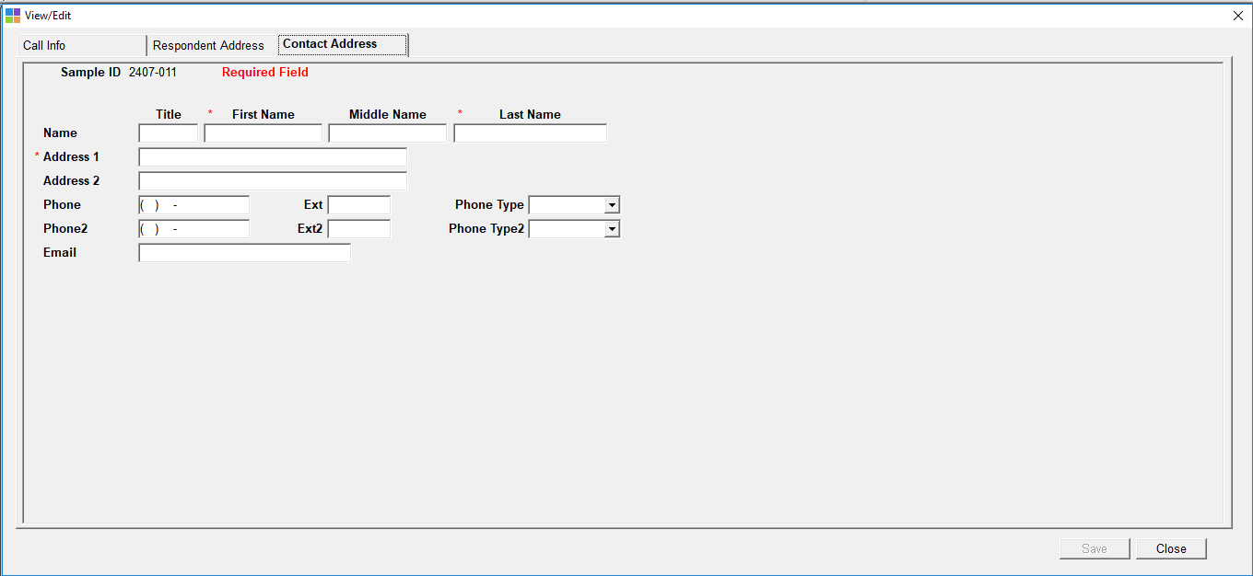

 The person type is C1.
The fields to be displayed are:

Label  * = required field |  SurveyTrak DB Column | Notes
Sample ID | tsample_line_address.vsamplelineid
Title | tsample_line_address.stitle
*First Name | tsample_line_address.vfirstname
Middle Name | tsample_line_address.vmiddlename
*Last Name | tsample_line_address.vlastname
Address 1 | tsample_line_address.vaddressline1
Address 2 | tsample_line_address.vaddressline2
Phone | tsample_line_address.sphone
Ext | tsample_line_address.sphoneextension
Phone Type | tsample_line_address.sphonetype1
Phone2 | tsample_line_address.sphone2
Ext2 | tsample_line_address.sphone2extension
Phone Type2 | tsample_line_address.sphonetype2
Email | tsample_line_address.vemail

All Notes
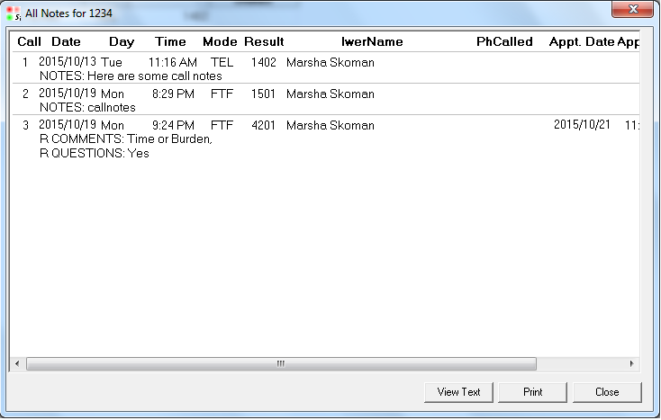

The fields to be displayed are:

Label |  SurveyTrak DB Column | Notes
Attempt | tcallinformation.ncallinfoid
Date | tcallinformation.dresultdate
Day | (calculated)
Time | tcallinformation.tresulttime
Method | tcallinformation.scallmode
Result | tcallinformation.sresultcodeid
Iwer Name | temployee.vfirstname, temployee.vlastname
PhCalled | tcallinformation.sphone
ApptDate | tcallinformation.dapptdate
ApptTime | tcallinformation.tappttime
Notes | tcallinformation.lvnotes + BCP pulls of observations (see list below) | See also Observations Instrument
RComm_Time, RComm_Interest, RComm_Confidential, RComm_Sensitive, RComm_Purpose, RComm_Govt, RComm_WhyMe , RComm_Voluntary , RComm_Incentive, RComm_None , RComm_Other, RComm_Spec, RQuestions

Call Wizard
Call Info Window
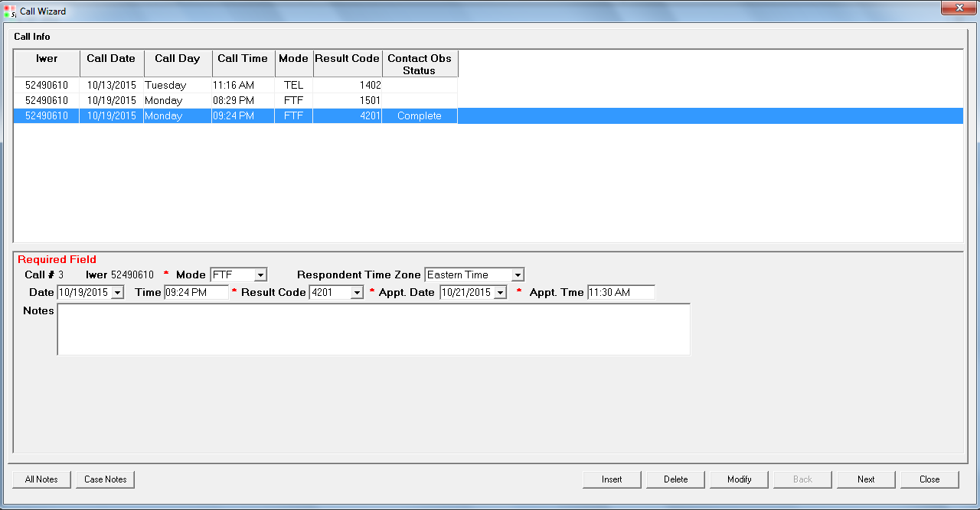

Top Pane
Column Heading |  SurveyTrak DB Column | Notes
Iwer | tcallinformation.sinterviewereremployeeid
Call Date | tcallinformation.dresultdate
Call Day | (calculated) | Calculated from tCallInformation.dResultDate
Call Time | tcallinformation.tresulttime
Method | tcallinformation.scallmode | 1=TEL, 2=FTF, 3=Email, 4=Admin, 5=Mail, 6=Text, 7=Video
Result Code | tcallinformation.sresultcodeid
Contact Obs Status | tcallinformation.siwerobsstatus | 0=Complete, 1=Suspend, 2=Problem, 3=Incomplete

Bottom Pane

Row | Label  *=required |  SurveyTrak DB Column | Notes
1 | Attempt | tcallinformation.ncallinfoid
1 | Iwer | tcallinformation.  sinterviewereremployeeid
1 | *Method | tcallinformation.scallmode | 1=TEL, 2=FTF, 3=Email, 4=Admin, 5=Mail, 6=Text, 7=Video
2 | Date | tcallinformation.dresultdate | When in Call Info after an interview: Default to date that IW was started and disable editing.
2 | Time | tcallinformation.tresulttime | When in Call Info after an interview:  Default to time that IW was started and disable editing.
2 | *Result Code | tcallinformation.sresultcode
2 | *Appt. Date | tcallinformation.dapptdate | Field activated only when the result code’s type is AP
2 | *Appt. Time | tcallinformation.dappttime | Field activated only when the result code’s type is AP
3 | Attempt Notes | tcallinformation.lvnotes

Contact Window Code
Contact Window Code = 1 if Result Date = Sunday thru Thursday & Result Time = 6:00PM thru 9:59PM
Contact Window Code = 2 if Result Date = Friday thru Saturday & Result Time = 6:00PM thru 9:59PM
Contact Window Code = 3 if Result Date = Saturday thru Sunday & Result Time = 9:00AM thru 5:59PM
Contact Window Code = 4 if Result Date = Monday thru Friday & Result Time = 9:00AM thru 5:59PM
Contact Window Code = 5 if Result Date = Sunday thru Saturday & Result Time = 10:00PM thru 8:59AM

Sunday | Monday | Tuesday | Wednesday | Thursday | Friday | Saturday
9am-6pm | 9am-6pm | 9am-6pm | 9am-6pm | 9am-6pm | 9am-6pm | 9am-6pm
6pm-10pm | 6pm-10pm | 6pm-10pm | 6pm-10pm | 6pm-10pm | 6pm-10pm | 6pm-10pm
10pm-9am | 10pm-9am | 10pm-9am | 10pm-9am | 10pm-9am | 10pm-9am | 10pm-9am

Pre-Disposition Actions
Pre-disposition actions appear in the call wizard after the interview and before the Call Info tab.
 Suspended Interview
- Respondent Address
- Call Info

 Completed Interview
- Respondent Address
- Contact Address
- Call Info
Post-Disposition Actions
Post-disposition actions appear in the call wizard after the result code is entered in Call Info tab.
 Observations will be required for every contact.
Result Codes | Post-Disposition Action(s)
1001 1005 | Contact Obs
4001 | Contact Obs
4201 | Contact Obs
4301 | Contact Obs
5001 | Contact Obs
6005 6007 | Contact Obs

Change Language
This project will use the Change Language feature. This project has two languages:
- English
- Nepali

Export/Import Sample
This project will use the Export/Import Sample (Offline Transfer) feature. Up to four fields can be specified for display in addition to Sample ID, Result, and Interviewer.
Export Window
 | Column Heading |  SurveyTrak DB Column
 | Sample ID | tsample_line.vsamplelineid
 | Result | tsample_line.sresultcodeid
 | Village/Town | tsample_line_address.vext_024
 | District | tsample_line_address.vext_009
 | State | tsample_line_address.vext_011
Import Window
 | Column Heading |  SurveyTrak DB Column
 | Sample ID | vsamplelineid
 | Result | sresultcodeid
 | Interviewer | siwersubscribeid
 | Name | vext_001
 | Village/Town | vext_002
 | District | vext_003
 | State | vext_004

Programmer note: Use the computed field vdynamic in the Export window (SQL select datawindow) to pass through information to the Import window (external datawindow).

Laptop Reports
This project will not need interviewer reports on the laptop.

Line Spawning
This project will not need to create additional sample lines on the laptop.

Related Case Details
This project will not need Related Case Details.

Result Codes
Current master list of valid result codes is located on the network:
L:\share\Survey Manager\ResultCodes\Final Master Result Code List 02_01_06.doc

Please note that result code descriptions cannot exceed 50 characters.

Result  Code | Description | Result Type | Report  Column | Modes:  1=TEL  2=FTF  3=Email  4=Admin  5=Mail  6=Text  7=Video | Obs Call Modes
0000 | Not Worked |  | NOATM
1001 | Complete Interview | CO,FI,IW | IWSALL,IWSCOM | 1,2,7 | 1,2,7
1005 | Partial Complete | IW,FI,CO,PR | IWSALL,IWSPTL | 1,2,7 | 1,2,7
1401 | Answering Machine/Service Reached, No Message Left | NC | NOCON | 1,4,6
1402 | Answering Machine/Service Reached, Message Left | NC | NOCON | 1,4,6
2005 | Respondent Not at Address (FTF only) | NC | NOCON | 2,4,5
2006 | Bad Address/Address Non-Existent | NC | NOCON | 2,4,5
3001 | No Contact, No One Home | NC | NOCON | 2,3,4,5,6,7
3003 | No Contact, Limited Access | NC | NOCON | 2,4,5
4001 | Contact No Resistance, General Callback | CO,CB | CONALL,CONNORSI | 1,2,3,4,6,7 | 1,2,3,6,7
4201 | Contact No Resistance, Appointment Made | CO,AP,CB | APTALL,CONALL,HRDAPT | 1,2,3,4,6,7 | 1,2,3,6,7
4301 | Contact Initial Refusal | CO,RE,CB | CONALL,CONRSI | 1,2,3,4,6,7 | 1,2,3,6,7
4901 | Hold, Technical Problem | HO | HLDALL,TECHLD | 3,4,6,7
4902 | Hold, Procedural Problem | HO | HLDALL,PROHLD | 3,4,6,7
5001 | Final Refusal, Respondent | CO,RE,FR,FI | NIREF | 1,2,3,5,7 | 1,2,3,5,7
6005 | NI, Language Barrier | CO,FI,NI | OTHNI | 1,2,3,5,7 | 1,2,3,5,7
6007 | NI, Other Reason | CO,FI,NI | OTHNI | 1,2,3,5,7 | 1,2,3,5,7
7001 | NS, House Vacant (FTF only) | FI,NS | NSOTH | 2
7003 | NS, Occupants Currently Reside Elsewhere | FI,NS | NSOTH | 1,2,3,5,7
8011 | NS, Deceased Respondent | FI,NS | NSALL | 1,2,3,4,6,7

Result Types
The following result types are used in reports.

Code | Description
AP | Appointment
CB | Callback
CO | Contact
EL | Eligible
FI | Final
FR | Final Resistance
HO | Hold
IW | Interview
NC | No Contact
NI | Non-interview
NS | Non-sample
PR | Partial Interview
RE | Resistance
TR | Locating

Result Flags
The following flags are set to true at the first occurrence of specified result type. They are only set once, they are never reset.

Flag | Result Type | SurveyTrak DB Column
Appointment Flag | AP | tsample_line.blapptflag
Contact Flag | CO | tsample_line.blcontactflag
Refusal Conversion Flag | RE, FR | tsample_line.blrcindflag
Locating Flag | TR | tsample_line.bltrackflag

