Signature Line Standards
As of April 12, 2021

- These rules do not apply to interviewers. Study rules should apply to any email correspondence with respondents.
- A signature is not always required. Typically used for external or more professional internal communications.
- Use a signature only in the first email, do not include in subsequent emails. Gmail has a setting for this.
- If you supply your office or personal phone number, make sure you record a professional voicemail greeting.
- Gmail allows you to create as many signatures as you need. In Settings, make the default “No Signature” and then use the signing tool when composing an email to add in the appropriate signature before sending, if desired.
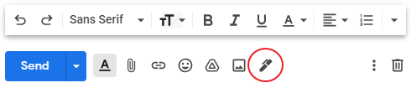

External | Internal
(U-M logo – optional)  [Name]  [University/Working Title*], Survey Research Operations  Survey Research Center, Institute for Social Research  University of Michigan  [address]  [phone**]  [pronouns – optional] | [Name]  [University/Working Title*]  Survey Research Operations, [SRO Office]  [phone**]  [pronouns – optional]

*University/Working Title: Official job title in MCommunity, e.g. Survey Specialist Intermediate
**Phone where you can be reached, not necessarily office phone

