Shortcode Creation Process
An awarded project will be assigned by Ryan to a Budget Analyst (BA). Ryan or Rolfe will forward the appropriate budget documents or the budget document location on O: Proposals. These documents should include a project establishment email (PAN or PAC), a budget values or budget shell doc, a budget justification doc and a workscope or transmittal memo at the minimum.
The BA will fill out a Footprints Project Initiation form with all the details given to them. This form can be found of the Financial Services website here:https://projects.isr.umich.edu/financial_services/Source_Code/Project_Forms.html
Once the Project Initiation form is submitted an email is sent to Dean Stevens with the request. Dean or his proxy will fill out shortcode request forms on L:Groups/SRO_Financial/_Shortcode_Setup folder. For multiple shortcodes use the template Example_shortcode_setup_form3.xls:
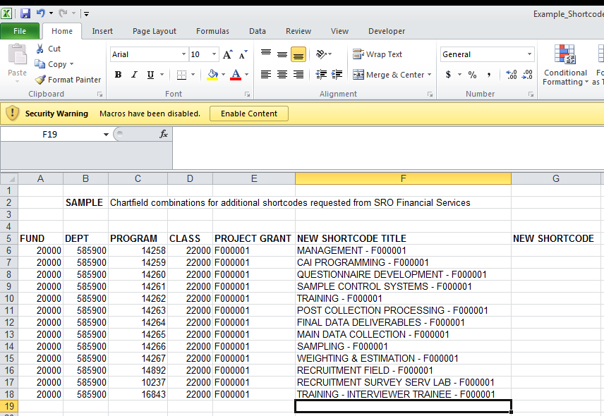

For single shortcodes or to change a program code use shortcode.xls:
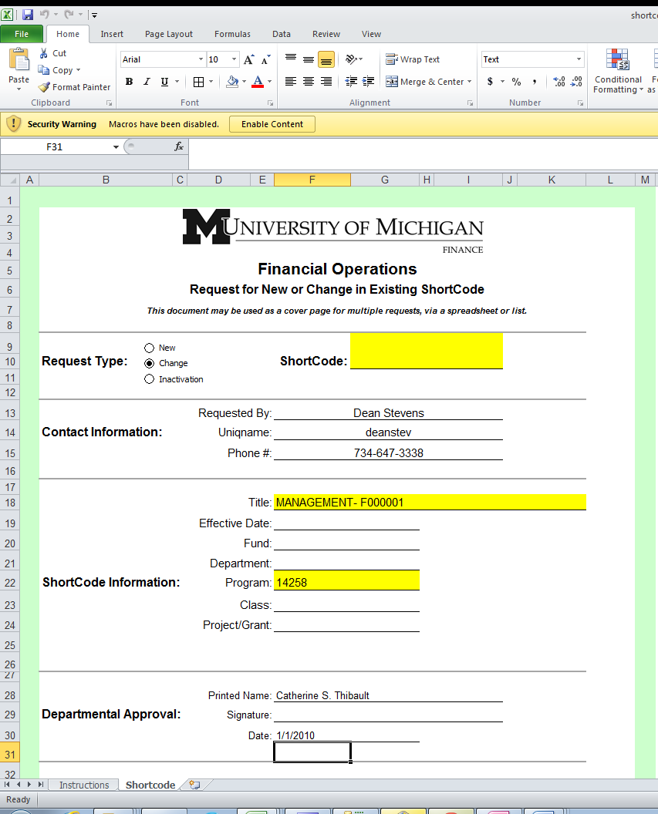

For shortcode requests on Project Grants that fall under:

- Fund 20000, or 25000 and
- Require one of the standard SRO program codes 10237,14258,14259,14260,14261,14262,14263,14264.14265,14266,14267,14892, 15592,15593,15594,15595,15749,15750,15751,15752,16843

SRO Financial Services will complete the required shortcode request forms (above). They will be approved by Ryan Neice and then forwarded electronically to Dean Stevens or Proxy. Dean will pass the request on to Matt Mueller, Nancy Tracy and cc: Ryan Niece for processing.
For shortcode requests that are:
- Not on Fund 20000 or 25000 or
- Are not using one of the standard SRO program codes SRO Financial Services will send the shortcode request form to shared services.
- Go to the following link and fill out the form: https://umichprod.service-now.com/ess/case_rp.do?sysparm_id=9d09f6496f427100fe2a884f8e3ee471

Once shortcodes have been received from Financial Operations (or shared services for Internal Grants), Dean will escalate the Footprints Initiation ticket to “Shortcodes Received” status and the sub ticket requests will be generated for Sprint, Authcodes, ET, CMC, and CRS work.

If the project grant is sponsored non-Federal work and has SO R&D and Clerical Fees Dean will send an email to Carolyn Batts informing her that SRO Finance will be responsible for monitoring these fees. This is done so we do not double charge a project, since ISR will charge the fee as the default on these projects.

To add the shortcodes to ET, refer to the ET procedure document. The two templates you will need to set up ET are located in the share drive location: L:Groups/SRO_Financial/WBS Code Request. The first template is the WBS Name Protocol.xls file.

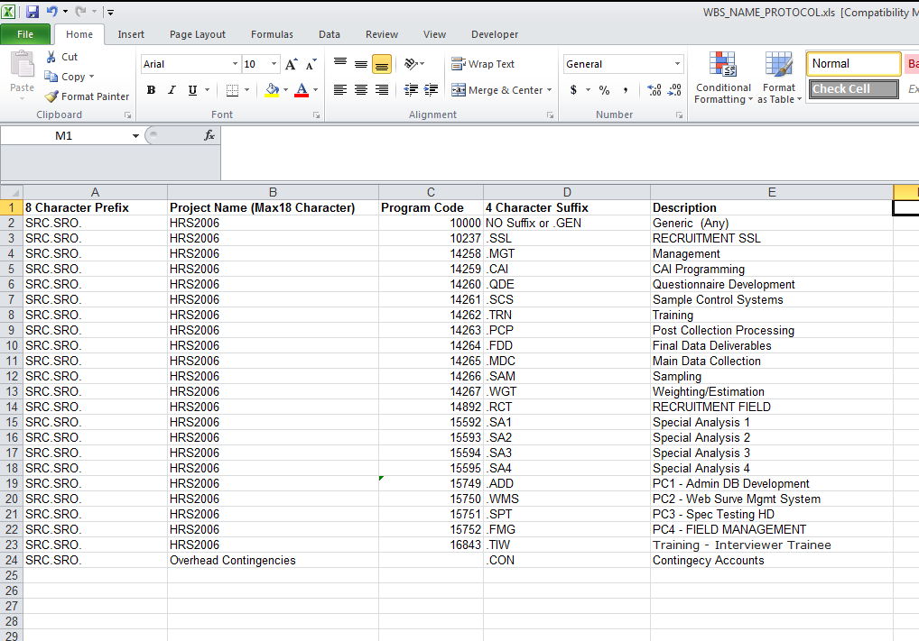

The second template makes it easier to fill out an individualized form. It is the WBS_Template.xls file.

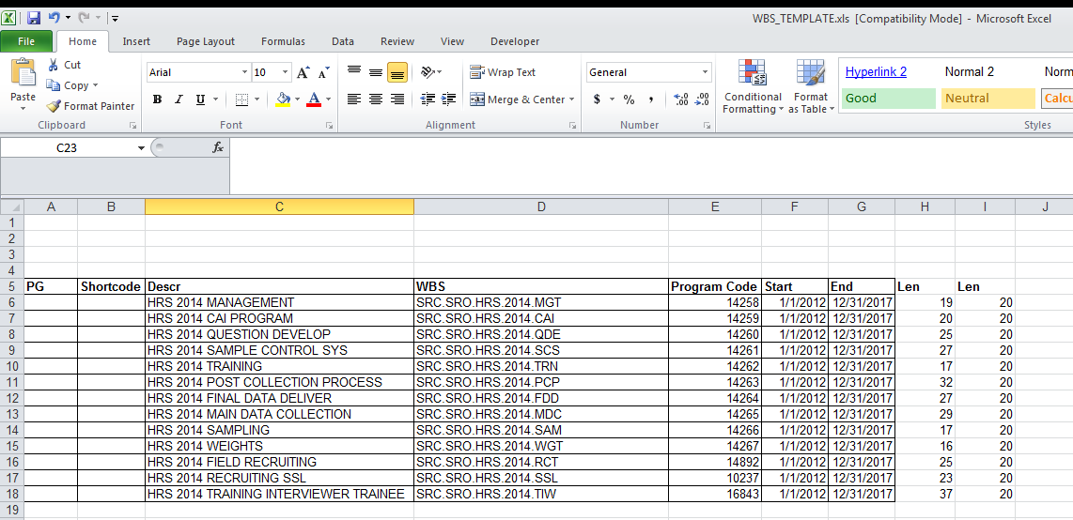

Once the project specific WBS template form is filled out, send an ET establishment email for sponsored project grant requests to the ISR_Accounting email address.

